Optical Rotation

Required prelab readings: McMurry Chapter 5; Padias, 56-60.

In this lab, you will measure the optical rotation of (R)-(-)-carvone and (S)-(+)-carvone mixture, calculate the specific optical rotation and enantiomeric excess (ee), and determine the percentage of (R)-(-)-carvone and (S)-(+)-carvone in the mixture.

Optical rotation, α, is the degree to which plane-polarized is rotated when passed through a through a sample. Optically active samples, such as solutions containing chiral molecules, rotate light in either a dextrorotatory (D-, d-, or (+); clockwise) or levorotatory (L-, l-, or (-); counterclockwise) fashion. Optical rotation can be used to distinguish between two enantiomers by measuring the direction of rotation. The specific optical rotation [α]_{D} is defined as the observed angle of optical rotation when plane-polarized light is passed through a sample with a concentration of 1g/mL and a tube length of 1 cm. The specific optical rotation of a pure compound is an intrinsic property of that compound at given wavelength and temperature. There is no relationship between R/S and D/L!

The optical rotation for a compound is reported as the specific rotation (see the equation below). This value compensates for observed rotations that would differ depending on concentration (which would be a function of both the solution concentration and path length). Like a melting point, it can be used to determine if a sample is pure or not.

- specific optical rotation (°)
α- measured optical rotation (°)
l - length of sample tube (dm)
c - concentration of sample (g/mL)
t – temperature (°C)
D - wavelength of light (usually indicated as ‘D’ for the sodium D line; λ = 589 nm)

The purity of optically active sample is reported in terms of enantiomeric excess (ee). Enantiomeric excess is defined as the difference between the mole fraction of each enantiomer. It is always a positive number.

Enantiomeric excess (% ee) can be determined from the specific optical rotation by using the following expression:

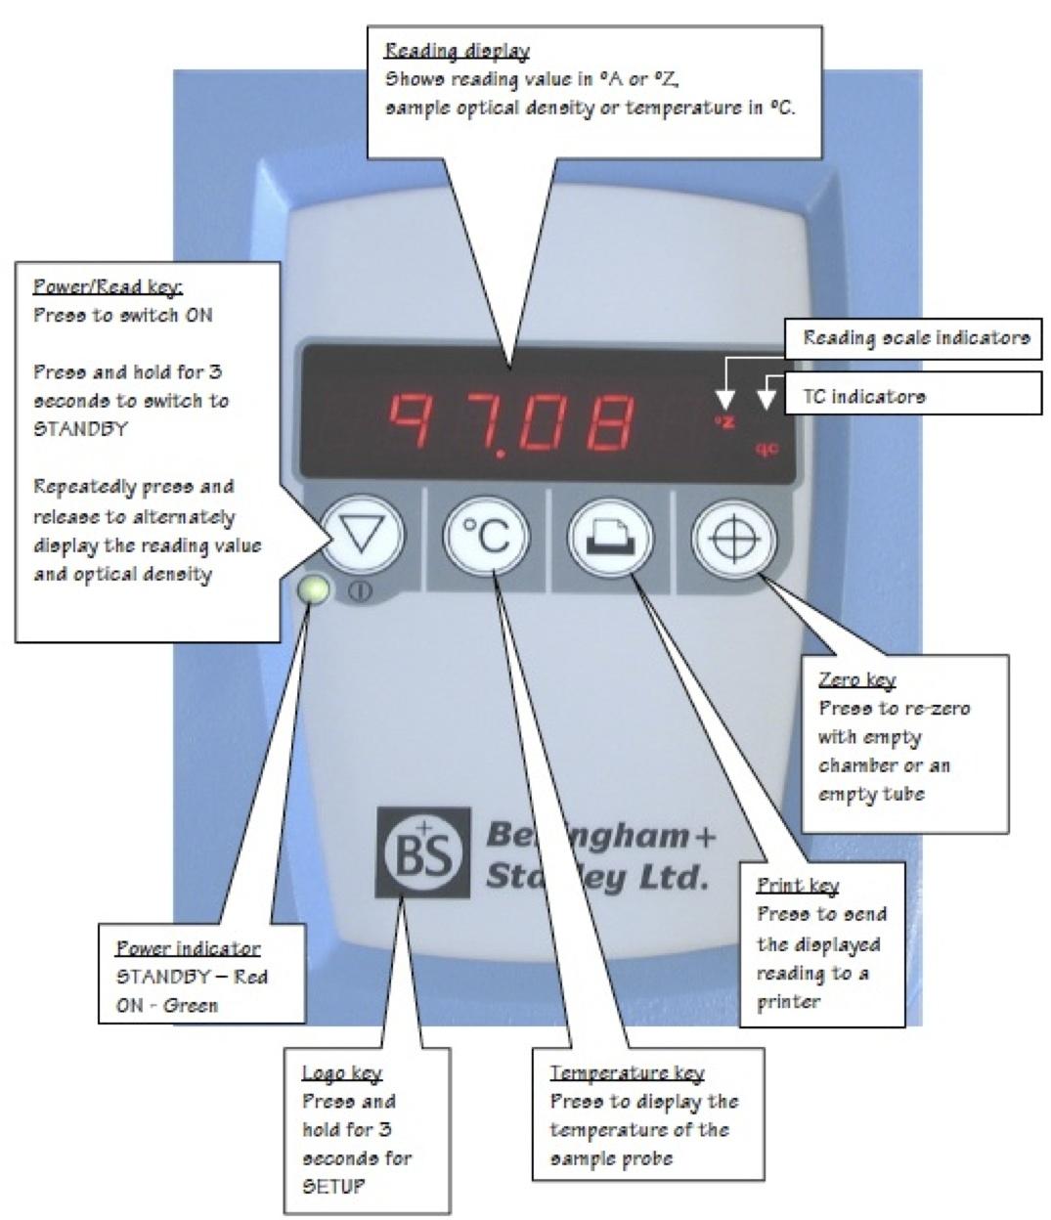

Sample Preparation
In this experiment each group will be given an unknown solution, originally prepared diluting a 6.25 g mixture of (R)- and (S)- carvone to a volume 25.0 mL with 70 % ethanol in water. Your goal will be to determine the specific rotation and %ee for your unknown. For pure (R)-(-)-carvone [α]_{D} = -60° .

Each person in the group will take a measurement for the unknown and the values will be averaged. First, press the temperature key and record the temperature. Load the blank making sure that no bubbles will be in the light path, close the doors and press the zero key. Once the instrument is zeroed, remove the blank and place the sample in its place. Again, avoid bubbles in the light path. Once the doors are closed the rotation will read out automatically. Record this value.
Optical Rotation
DATA SHEET

Name: |  | Section: |  | Date:

Unknown #:

(R)- carvone |  |  | (S)- carvone
Structure (use chemical drawing software) |  |  | Structure (use chemical drawing software)
Smell : |  |  | Smell :
Molecular weight : |  |  | Molecular weight :

Optical rotation measurements:
Cell length (dm):
Solution concentration (g/mL):

Sample* | α (°) | [α]_{D} (°) | % ee | % (R)-(-)-carvone | % (S)-(+)-carvone
Pure R |  |  | 100 % | 100 % | 0 %
Pure S |  |  | 100 % | 0% | 100 %
Unknown average:
*identify the reading you took with an *

Calculations
a. Calculation of specific optical rotation for your reading.

b. Calculation of enantiomeric excess (ee) for your reading (use the value of pure R / S from the table).

c. Calculation of %R and %S for your reading.

Postlab questions:

1. The LD₅₀ (“Lethal Dose, 50 %”) is a value used in toxicology which gives the amount of a substance required to kill 50 % of a test population. It is usually reported based on body weight. For racemic carvone LD₅₀ is reported as 1640 mg/kg.
a. Would you consider carvone to be toxic to an average person? Briefly explain your answer.

b. Would you expect this the LD₅₀ value to be the same for each enantiomer? Briefly explain your answer at the molecular level in stereochemical terms.

2. Draw structures for the bioactive forms of drugs below using chemical drawing software. Be sure to clearly show the correct stereochemistry (wedges and dashes) and assign the absolute configuration at each chiral carbon.
a. dexibuprophen (non-steroidal anti-inflammatory).
b. Levocetirizine (3rd Generation antihistamine)
c. Tamiflu (Antiviral to treat influenza A and B)
d. Cialis (for the treatment of erectile disfunction)
e. Zoloft (Antidepresent)

