Compound Identification by NMR Spectroscopy

Required pre-lab readings: McMurry Chapter 11; Padias pp 77-100; On-line handout: Running the NMR

Required pre-lab assignments: calculate coupling constant, calculate DOU (post-lab question 7)

The goals of this experiment are to learn to prepare NMR samples, run the NMR spectrometer and use NMR data to determine the structures of number of compounds.

Nuclear Magnetic Resonance (NMR) is a nuclear phenomenon that occurs when an atomic nucleus possessing magnetic momentum ‘spins’ about its nuclear axis.. Only those nuclei with an odd number of protons and/or an odd number of neutrons (¹H, ²H, ¹³C, ¹⁴N, ¹⁹F, ²⁹Si, ³¹P, …etc.) exhibit NMR. Note that the most abundant isotope of carbon (¹²C) does not exhibit NMR.

NMR was discovered jointly by E. M. Purcell (at Harvard) and Felix Block (at Stanford) in the early 1940’s. They shared the 1952 Nobel Prize in physics for their discovery. Three additional Nobel Prizes have been awarded to people for work on NMR (or its medical application, MRI). The first commercial NMR’s were sold in the early 50’s by the Varian Corporation.

Important Concepts

- Magnetically-equivalent nuclei (i.e., the two methyl groups in propane) are chemical-shift-equivalent (they give only one chemical shift in the NMR spectrum).
- The total number of signals in the NMR represents the total number of sets of chemically-equivalent nuclei in the molecule. Therefore, propane, with three carbons and eight hydrogens, exhibits just two signals in both its ¹³C- and ¹H-NMR spectra.
- The chemical shift of each signal provides information about the environment around each set of magnetically-equivalent nuclei.
- In ¹H-NMR spectroscopy, the area under each peak is proportional to the number of hydrogens in each set.
- The splitting of ¹H-NMR signals into multiplets (doublets, triplets, etc.) typically reflects the number of non-equivalent hydrogens on adjacent carbons (McMurry, Chapter 11).
- The coupling constant, J, is a measure of the interaction between a pair of coupled protons.
The coupling constant is calculated by the following formula:
J (Hz)= Chemical shift difference(ppm) × Field strength(MHz)

Pre-lab Question
The following NMR was obtained on a 400 MHz instrument and the chemical shift was in the unit of ppm. Calculate its chemical shift (middle of the quartet) and coupling constant.

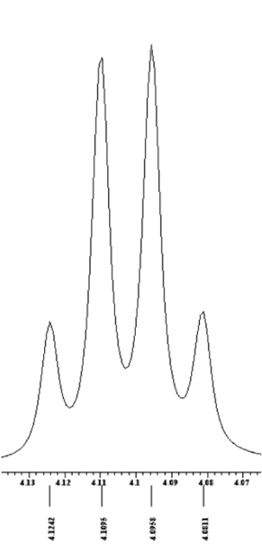
3.7097 | 3.6927 | 3.6757 | 3.6587

NMR Data Summary

For 310 and 311 labs where you take or are given a NMR spectrum, you will be asked to fill out a table. An example is shown below (see next page for the corresponding ¹H NMR). Pay close attention to the formatting within the table as described below. This formatting should be used each time you fill out a table for an NMR spectrum.
1. δ is the chemical shift in the unit of ppm. Each non-equivalent type of H has a single δ value.
Chemical shifts should be listed from high δ to low δ.
Chemical shifts for ¹H NMR spectra are to be reported to two decimal places.
Chemical shifts for ¹³C NMR spectra are to be reported to one decimal place.
2. Multiplicity is the number of peaks a type of H’s is split into.
s – singlet, one peak.
d – doublet, two peaks of equal intensity
t – triplet, three peaks of 1:2:1 intensity
q – quartet, four peaks of 1:3:3:1 intensity
m – multiplet, more than four peaks or undefined splitting
3. Couplings constant are to be reported in Hz to one decimal place.
4. Number of H’s: determined from integration, representing the actual number of H’s at certain chemical shift.
5. Identification: a, b, c… correlates H’s in the structure with chemical shifts in the spectrum.

δ (ppm) | Multiplicity | Coupling Constant J (Hz) | Number of H’s | Identification
4.10 | q | 7.4 | 2 | b
2.03 | s | N.A. | 3 | c
1.24 | t | 7.4 | 3 | a
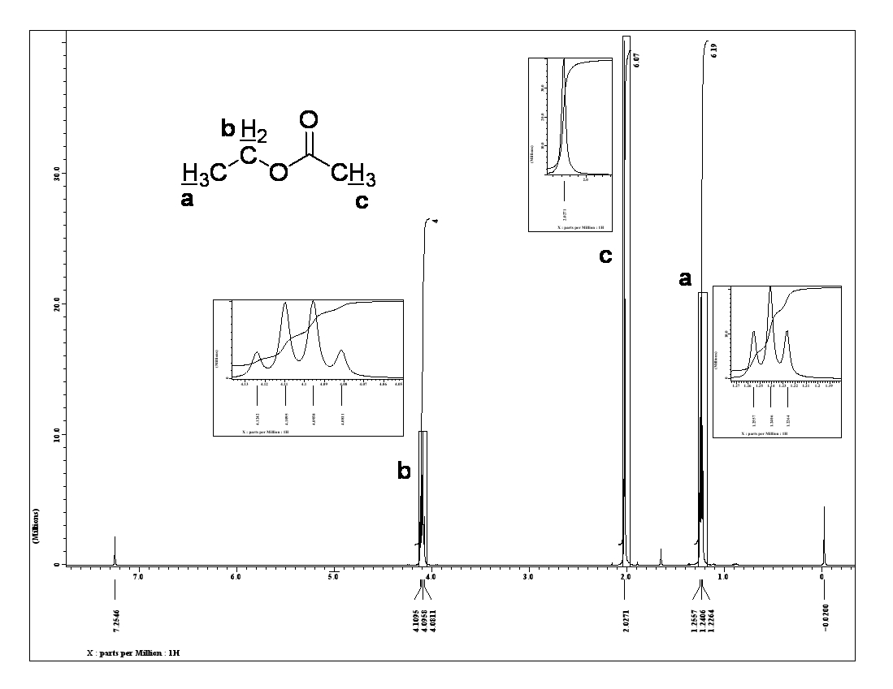

Procedure

Sample Preparation for NMR Spectroscopy

NMR spectra are taken as dilute solutions in solvents in which all of the hydrogens have been replaced by deuterium (CDCl₃, CD₂Cl₂, C₆D₆, acetone-d6, etc.) Duterium is used for the solvent because, although NMR active, the resonance frequency of deuterium is very different from that of a proton, so it generally does not show up on a proton spectrum. For this experiment you will be preparing “model solutions” using colored solids and liquids that can be compared to standards. If the concentrations are correct, the solutions will look similar in color.

Working in pairs you will prepare four samples. Because 99% of hydrogen is the ¹H isotope very little sample is needed for a ¹H NMR sample. Prepare the ¹H NMR sample of the solid by weighing out 5 mg of acetaminophen (colored with blue food coloring) into a vial and then adding 0.7 mL of the NMR solvent. Once the solid is dissolved use a Pasteur pipet to transfer the sample into an NMR tube and cap the tube. Because only 1% of carbon is ¹³C, ¹³C samples are generally more concentrated. Prepare a ¹³C NMR sample of the solid using the same procedure, but with 50 mg of solid. To prepare the ¹H NMR sample of the liquid, place one drop of liquid into a vial and add 0.7 mL of the NMR solvent. Mix the solution well with a Pasteur pipet and transfer the sample into an NMR tube and cap the tube. To prepare the ¹³C sample, repeat the procedure with 5 drops of the liquid. Show you samples the your instructor to be compared with the standards.

Clean up of NMR Tubes
Remove cap and pour contents of the NMR tube into the waste container. Fill the NMR tube about half way with acetone using the acetone squirt bottle provided. Empty into the waste container. Repeat two more times. Clean the outside of the tube with acetone if it appears to be dirty. Now place the NMR tube upside down in the beaker provided. Leave the cap in a second beaker. If you think some of your NMR solution has come in contact with the cap, wash the cap with acetone.

Identification of an Unknown
In this experiment, each group will select a previously prepared unknown NMR sample and take its ¹H- NMR spectrum. If time permits the unknown’s ¹³C- NMR spectrum will also be taken, the ¹³C spectrum will be provided by the instructor. This information will be used to determine the structure of the unknown. The unknown will have one of the following molecular formulas:

C₂H₃Cl_{3,} C₄H₁₀O, C₄H₈O₂, C₄H₈O, C₇H₆O₂, C₉H₈

NMR
DATA SHEET

NAME: |  | Section:

Unknown number:

Draw the structure of your unknown below with all non-equivalent H’s labeled (a, b, etc.) for NMR identification. Redraw the structure and labels directly on the ¹H NMR spectrum. Match each label with the corresponding peak(s) in the spectrum by writing the appropriate letter above the associated peak. Label the peak(s) on the spectrum that corresponds to the NMR solvent used by writing the solvent above it (them).

Complete the table below for the ¹H NMR spectrum. If necessary, use the expanded spectra for multiplicity and coupling constants. For Identification, use the same a, b, etc. that is used in the structure above and on the spectrum. Do not include the solvent peak in the table.

δ (ppm) | Multiplicity | Coupling Constant J (Hz) | Number of H’s | Identification

Sample calculations of chemical shift and coupling constant:

Draw the structure of your unknown below with all non-equivalent C’s labeled (a, b, etc.) for NMR identification. Redraw the structure and labels directly on the ¹³C NMR spectrum. Match each label with the corresponding peak(s) in the spectrum by writing the appropriate letter above the associated peak. Label any solvent peaks in the spectrum writing the solvent above them.

Complete the table below for the ¹³C NMR Spectrum. For Identification, use the same a, b, etc. that is used in the structure above and on the ¹³C spectrum. Do not include solvent peaks in the table.

δ (ppm) | Identification |  | δ (ppm) | Identification

Post-lab Questions:

1. The deuterated forms of the solvents below are common solvents for NMR. Commercially available deuterated solvents normally have 99.0 ~ 99.96% deuterium, meaning trace amounts of non-deuterated solvents are also present. What are the ¹H and ¹³C chemical shifts produced by these residual solvents? Also, trace amounts of water are often found in ¹H spectra taken in CDCl₃ and d6-DMSO. What is the chemical shift of water in these solvents? Tables of these values can be found on line or in the lab.

residual solvent | ¹H δ (ppm) | ¹³C δ (ppm) |  | Water in … | ¹H δ (ppm)
CHCl₃ |  |  |  | CHCl₃
DMSO |  |  |  | DMSO
CH₂Cl₂

2. Explain why all protons in a molecule do not absorb at the same radio frequency energy. In other words, why do non-equivalent protons have different chemical shifts?

3. Describe the effect of the magnet’s power, B₀, on the separation of peaks arising from non-equivalent nuclei in the frequency (Hz) spectrum. Consider the nuclei in the absence of any spin-spin splitting.

4. Describe the effect of the magnet’s power, B₀, on the chemical shift (δ; ppm spectrum)? Explain

5. Describe the effect of the magnet’s power, B₀, on the separation of peaks arising from spin-spin splitting in the frequency (Hz) spectrum.

6. Describe the effect of the magnet’s power, B₀, on the separation of peaks arising spin-spin splitting in the NMR (ppm) spectrum? Explain

7. You will find the ¹H and ¹³C NMR spectra of the nine additional compound posted on the 310L website (A-I); each compound has one of the following formulas: C₂H₃Cl_{3,} C₄H₁₀O, C₄H₈O₂, C₄H₈O, C₇H₆O₂, C₉H₈. Prior to coming to lab, print out the post-lab spectra and calculate the degrees of unsaturation for the preceding formulae.

You will turn in only one ¹H and ¹³C spectrum for each compound. Use a spectrum that allows all of the peaks and assignments to be seen.

For each spectrum (A-I)
(1) Draw a structure consistent with each ¹H spectrum directly on the spectrum.
- Use the a, b, c… system to label the sets of non-equivalent protons in your structure.
- Place the letters over the corresponding peak(s) in the spectrum.
- Label any NMR solvent peaks on the spectrum by writing the solvent above them.
(2) Redraw the structure on the corresponding ¹³C spectrum.
- Use the a, b, c… system to label the sets of non-equivalent carbons in your structure.
- Place the letters over the corresponding peak(s) in the spectrum.
- Label any NMR solvent peaks on the spectrum by writing the solvent above them.

