THE HUMAN SIDE OF WORK
Psychology 302
Spring 2019 –Seven Week Session – Online Course

Course Description: PSY 302 The Human Side of Work (3,0,3) Psychology of work behavior; interpersonal relations and organizational effectiveness; communication, morale, stress, leadership styles, values, ethics, problem solving techniques, and cross-cultural aspects of the work experience. The approach to learning is experiential and may include some field assignments. PREREQ: PSY 100.

Purpose of Course: To provide an applied course in the psychology of work behavior for psychology majors, students from other disciplines, and other interested individuals.

Instructor: George Manning website: www.nku.edu/~manningg
Phone: 859-572-5443, 207-664-9787 e-mail: manningg@nku.edu

Method of Instruction: Participative and personalized; students will "learn by doing."

I hear and I forget;
I see and I remember;
I do and I understand.
Confucius 551BC-479BC

Lecture, tutorials, discussion, and learning activities will be methods of instruction.

Course Resources:

Required Text—The Art of Leadership, 6th edition, McGraw-Hill, 2019.

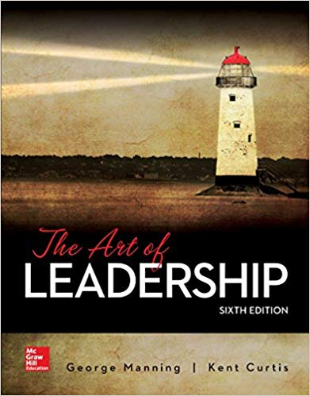
Student Learning Outcomes:

Student learning outcomes include knowledge and application of principles and practices in the psychology of work behavior. Students will develop the ability to comprehend, analyze, synthesize, and evaluate information in the following content areas: work morale, productivity, effective leadership, organizational climate, ethics at work, the diversity challenge, managing complex change, adaptive capacity, performance improvement, and working across cultures.

Methods of Assessing Student Learning:

1) Four exams will be used to assess knowledge, comprehension, and application of the psychology of work behavior.

1st Quarter Exam includes multiple choice and essay questions = 100 points (Based on text) 20% of grade

2nd Quarter Exam includes multiple choice and essay questions = 100 points (Based on text) 20% of grade

3rd Quarter Exam includes multiple choice and essay questions = 100 points (Based on text) 20% of grade

4th Quarter Exam includes multiple choice and essay questions = 100 points (Based on text) 20% of grade

2) Participation (20% of grade) will be based on: a) completion of leadership case study and b) completion of seven (7) reaction reports on assigned text, videos and cases. Each 1 page reaction paper is worth 10 points and the 3 page leadership case study is worth 30 points. (100 points)

Grade Scale for plus/minus Scale Based on 500 points
4.0 = A  3.667 = A-  3.333 = B+  3.000 = B  2.667 = B-  2.333 = C+  2.000 = C  1.667 = C-  1.333 = D+  1.000 = D  0.000 = F | A 93% and up  A- 90-92.9%  B+ 87-89.9%  B 83-86.9%  B- 80-82.9%  C+ 77-79.9%  C 73-76.9%  C- 70-72.9%  D+ 67-69.9%  D 60-66.9%  F 59% | 465-500 (A)  450-464 (A-)  435-449 (B+)  415-434 (B)  400-414 (B-)  385-399 (C+)  365-384 (C)  350-364 (C-)  335-349 (D+)  298-334 (D)  297 and below (F)

Student Requirements:

1) Read the text and complete 4 exams based on the text.
2) View online lectures and eight tutorials.
3) View related videos and write reaction reports.
4) Write 3 page leadership case study
5)

Credit Hour Policy
Credit Hour Policy Statement

In accordance with federal policy, NKU defines a credit hour s the amount of work represented in the achievement of student learning outcomes (verified by evidence of student achievement) that reasonably approximates one hour (50 minutes) of classroom instruction and a minimum of two hours of out-of-class student work. For every course credit hour, a typical student should expect to spend at least three hours per week of concentrated attention on course-related work including, but not limited to, class meeting time, reading, reviewing, organizing notes, studying and completing assignments. At least an equivalent amount of time is expected for other academic activities such as online courses, laboratory work, internships, practica, studio work and other academic work leading to the award of credit hours.

Estimates of time required for a typical student to complete course expectations are as follows:

- Required lectures and online communication with instructor: 3 hours x 7 week s= 21 hours
- Required text and online communication with instructor: 6 hours x 7 weeks = 42 hours
- Required related readings and videos, and online communication with instructor: 5 hours x 7 weeks = 35 hours
- Required reaction papers: 3 hours x 7 weeks = 21 hours
- Required course project/paper: 15 hours
- Required exams: 2 hours x 4 quarters = 8 hours
Total 142 hours

All students must meet the same requirements.

NOTE: Students with disabilities (sight, hearing, etc.)—please call this to my attention so assistance can be provided.

NOTE: This syllabus should be viewed as a working plan for the semester. Circumstances may necessitate changes in the plan during the course of the term. Changes will be at the discretion of the instructor in consultation with the class.

NOTE: One core value held by the Department of Psychology is the importance of effective writing. Our expectation for students in Psychology courses is that written assignments be prepared according to accepted college-level standards for English usage, including grammar, punctuation, spelling, sentence structure, and composition. That is, students will be expected to proofread, edit, and correct their own work in these areas prior to submitting assignments for grading and evaluation. Examples of these assignments may include, but are not limited to, research papers, article summaries, group projects, class papers, take-home essay examinations, and independent study projects. Assignments that do not appear to have been proofread, edited, and corrected prior to submission may be returned to the student for revision before grading, at the discretion of the instructor, or may receive a lower grade that reflects the level of writing skills demonstrated. Experience suggests that writing clearly, concisely, and compellingly requires thought and organization. Give yourself time to organize, draft, revise, and proofread. The requirement of using the library/writing lab resources will be assigned during the course of the semester.

Student Honor Code:
The work you will do in this course is subject to the Student Honor Code (http://scra.nku.edu/policies/student-rights.html). The Honor Code is a commitment to the highest degree of ethical integrity in academic conduct, a commitment that, individually and collectively, the students of NKU will not lie, cheat, or plagiarize to gain an academic advantage over fellow students or avoid academic requirements.

Disabilities Disclosure Statement:
Students with disabilities who require accommodations (academic adjustments, auxiliary aids or services) for this course must register with the Office of Disability Services. Contact the Office of Disability Services immediately in University Center suite 320 or call X-6373 for more information. Verification of your disability is required in the Office of Disability Services for you to receive reasonable academic accommodations. Visit the disability services website at www.nku.edu/~disability/<http://www.nku.edu/~disability/>.

Online Evaluation:
Northern Kentucky University takes Instructor and Course Evaluations very seriously as an important means of gathering information for the enhancement of learning opportunities for its students. It is an important responsibility of NKU students as citizens of the University to participate in the instructor and course evaluation process. During the two weeks* prior to the end of each semester classes, you will be asked to reflect upon what you have learned in this course, the extent to which you have invested the necessary effort to maximize your learning, and the role your instructor has played in the learning process. It is very important that you complete the online evaluations with thoughtfully written comments.

Starting Spring semester 2011, students who complete an evaluation for a particular course (or opt out of doing so in the evaluation) will be rewarded for their participation by having access to their course grade as soon as that grade is submitted by the instructor. On the other hand, any student who does not complete the course evaluation (or opt out of doing so in the evaluation) should expect to incur a two week delay in access to his or her course grade beyond the university's official date for grade availability.

To complete online evaluations go to http://eval.nku.edu. Click on "student login" and use the same USERNAME and PASSWORD as used on campus.

Student evaluations of courses and instructors are regarded as strictly confidential. They are not available to the instructor until after final grades are submitted, and extensive precautions are taken to prevent your comments from being identified as coming from you.
*Seven-week classes will be given one week before classes end to complete evaluations.

Hardware/Software Requirements:
- A reliable and convenient connection to the Internet
- Windows XP, Vista, or Windows 7
- Mac OSX 10.5 “Leopard” or Mac OSX 10.6 “Snow Leopard”
- Blackboard requires the latest version of Sun JRE 6 which can be downloaded at: http://www.oracle.com/technetwork/java/javase/downloads/index.html
- Check your browser settings by clicking the Test Browser button located on the Blackboard login page.
- Reliable E-mail account - Students automatically receive an NKU E-mail address when registered for classes at NKU which is loaded into Blackboard. All corresponds will be sent to your NKU email address. If you prefer to receive email at a different email address, you MUST set your NKU email to be forwarded to your preferred email account. To set email forwarding, go to https://access.nku.edu/secureapps/email/forward/login.php . Students are responsible for course related email received through their NKU email account.
- Microsoft Word 2000 or newer
- Internet Software >Microsoft Internet Explorer Version 7 or later (free download at http://www.microsoft.com/downloads/en/default.aspx ; Firefox 3.0 or later (free download at http://www.mozilla.com/en-US/). For a complete list of supported browsers, please visit http://it.nku.edu/itsc/training/Training_Docs/Bb9-1browsers.pdf
- Adobe Acrobat Reader 7.0 or later >free download at http://www.adobe.com/products/acrobat/readstep2.html
- PowerPoint viewer >free download at http://www.microsoft.com, under Resources> Downloads, under Products>Technology> PowerPoint
- Reliable Printer
- Virus Scan Software

Required Competencies:
- Ability to navigate the Web (use a browser) and handle multiple open windows
- Ability to browse web pages
- Knowledge of how to create, send, open, close, and save files and attachments
- Ability to attach documents to E-mail and send
- Basic word processing skills

Netiquette/Email:
Every time you link and enter your NKU virtual classroom and supporting NKU sites, your communications are open for others to see. If you are not careful, these communications may
violate NKU and class policies. Online communication examples are: emails, Discussion Boards, Chat Rooms, Attachments, Links, Virtual Chats, and Instant Messages.
DO NOT USE LANGUAGE THAT IS:
- Harassing
- Threatening
- Discriminatory
- A copyright violation
NKU AND PSY 302 CLASS POLICIES PROHIBIT:
- Sending obscene pictures
- Sending obscene jokes
- Linking to adult sites
- Sending offensive email
- Insulting anyone
- Insulting anyone's ideas or thoughts (disagreement is acceptable, insulting is not). If you have any doubts, don't send it!

SCHEDULE OF EVENTS

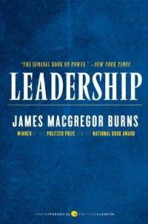 | Jan 14 | - Class begins; welcome; course overview  - Read syllabus online  - View attend Tutorial #1 (Chapters 1, 2, 3 – 36.31 minutes) – video skit optional  - Read the biography of James Autry  - Read text—Preface and Chapter 1: The Importance of Leadership  - See especially Satisfactions and Frustrations of Leaders, page 8  - View Winston Churchill: Walking with Destiny video online  - Assignment: Leadership Case Study, including identity of leader; where leader learned to lead; what leader wants in a leader; relationship between leadership effectiveness, employee morale, and work performance; and advice for career success. (3 pages) Due Jan 30
 | Jan 16 | Part 1: Leadership Variables  - Read text—Chapter 2: The Leadership Equation  - Read the biography of James MacGregor Burns  - See especially Leadership Contingency Theory and Transformational Leadership, pages 21 - 25  - View The Art of Caring Leadership video online  - Submit 1 page reaction paper #1 including your own core leadership values and discussion of the “Caring Confrontation” Due Jan 18
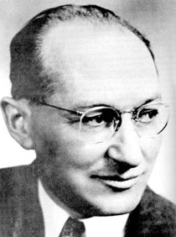
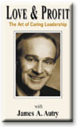
- Read text—Chapter 3: Leadership Qualities, Characteristics of Followers and Situational Factors
- Read the biography of Kurt Lewin
- See especially “negative” leadership, pages 31 - 32
- Complete Reflection Points on pages 53 - 54
- Complete Indicator of Multiple Intelligences—assessment (text), page 39
- View Embrace the Shake video online
- View University of Texas at Austin 2014 Commencement Address – Admiral William McRaven: Make Your Bed (19:26 minutes 6, 626,630 views)

 | Jan 18 | Part 2: The Power of Vision  - View attend Tutorial #2 (Chapter 4 – 15:31 minutes) – video skit optional  - Read text—Chapter 4: The Importance of Vision and The Motive to Lead  - Read biography of Joel Barker  - See especially The Importance of Alignment, Prioritization, and Execution pages 64 - 65  - See especially Why Create a Vision and Requirement for an Effective Vision, pages 65 - 67  - View The Power of Vision video online  - Submit 1 page reaction paper #2 including a statement of your personal and/or organizational vision and starfish example Due Jan 23
 | Jan 22 | Last day to drop a course without a grade appearing on transcript  Last day to drop a course with a 50% tuition adjustment
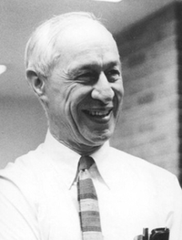 | Jan 23 | Part 2 continued:  - Complete Social Motives in the work Setting—Assessment (text), page 68  - View attend Tutorial #3 (Chapter 5 – 12:39) – video skit optional  - Read text—Chapter 5: Organizational Climate  - Read biography of Rensis Likert  - See especially Building Community in The Workplace, pages 80 - 83  - Complete Organizational Climate Questionnaire—assessment (text), page 74  - Complete Reflection Points on pages 85 - 86  - View My Mom’s Motorcycle video online  - View Margaret Heffernan: Forget the Pecking Order at Work (Ted talk 2017 15:45 minutes)

 | Jan 25 | 1st Quarter Exam (Intro, Part 1 and Part 2 )
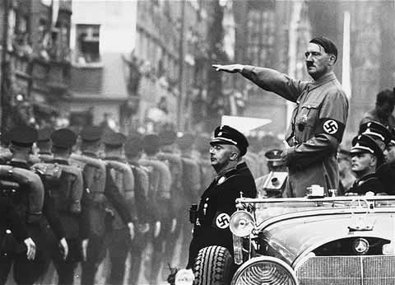 | Jan 28 | Part 3: The Importance of Ethics  - View attend Tutorial #4 (Chapters 6 and 7 – 21:47 minutes) – video skit optional  - Read text—Chapter 6: Leadership Ethics  - Read biography of Lawrence Kohlberg  - See especially Ethics and The Legal Department page 103  - View Moral Development video online  - View Buzzer video online  - Submit 1 page reaction paper #3 including discussion of levels of morality in personal and/or historic incidents  due Jan 30
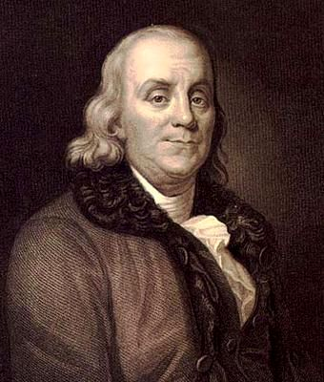 |  | - Read text—Chapter 7: The Role of Values and Ethics at Work  - Read Peter Drucker biography  - See especially Values and The Importance of Courage, page 106  - Complete Personal Values—Assessment (text), page 114  - View Ethics and Money video online  - View John Mack on Saving Morgan Stanley video online  - Complete Reflection Points on pages 139 - 140
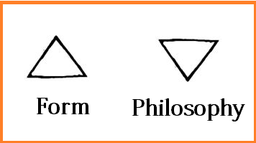 | Jan 30 | Part 4: The Empowerment of People  - Submit 3-page leadership case study.  - View attend Tutorial #5 (Chapter 8 – 13:43 minutes) – video skit optional  - Read text—Chapter 8: Leadership Authority  - Read Robert Greenleaf biography  - See especially Servant Leadership, pages 145 - 149  - See especially Psychological Size and Leadership Effectiveness, pages 156 - 159  - View Free Hugs video online  - View attend Tutorial #6 (Chapter 9 – 27:46 minutes) – video skit optional  - Read text—Chapter 9: Empowerment in the Workplace and The Quality Imperative  - Read W. Edwards Deming biography  - See especially Communication Problems and Solutions, pages 165 - 168  - See especially The High Performance Workplace, pages 168 - 169  - View Johnny The Bagger video online  - View Smile video online

 | Feb 1 | Part 4 continued:  - View attend Tutorial #7 (Chapter 10 – 31:30 minutes) – video skit optional  - Read text—Chapter 10: Effective Leadership and Human Relations  - Read Irving Janis biography  - View Groupthink video online  - Submit 1 page reaction paper #4 including discussion of “groupthink” in personal and/or historic incidents  Due Feb 4  - Complete Reflection Points on pages 183 – 184
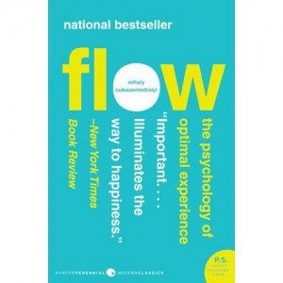 | Feb 4 | Part 5: Leadership Principles  - Read Douglas McGregor biography  - Complete The Leadership Report Card—assessment (text), page 188  - See especially Psychological Health and the Concept of Flow, page 201 - 203  - See especially The Art of Listening 213 - 216  - See especially The Evolving Context of Human Relations 218 - 219  - View Empathy (The Cleveland Clinic 4.50 minutes)
 | Feb 6 | Part 5 continued:  - View attend Tutorial #8 (Chapter 11 – 26:44 minutes) – video skit optional  - Read text—Chapter 11 The Team Concept  - See especially Excellent Teams and Positive vs. Negative Group Member Roles, page 226 - 228  - See especially Stages in The Life of a Group, pages 240 - 243  - View Your Summit Awaits video online.  - Submit 1 page reaction paper #5 including application of truth, perspective, trust, focus, and humility to achieve a personal or organizational summit Due Feb 8  - Complete Reflection Points on pages 259 260
 | Feb 8 | 2nd Quarter Exam (Parts 3, 4, & 5)
 | Feb 11  Feb 11  Feb 13 | Part 6: Understanding People  - View attend tutorial #9 (Chapters 12 and 13 – 35:43 minutes) – video skit optional  - Read text—Chapter 12: Human Behavior and The Art of Persuasion  - Read the biography of Abraham Maslow  - See especially Emotional Intelligence pages 281 - 285  - Complete Motivation at Work—assessment (text), page 270  - View Maslow video online  - View Drive video online  - View The Transformational Power of Positive Relationships video online  Last day to drop a course with a grade of W  Part 6 Continued:  - See especially The Effective Use of Words and Joshua Lawrence Chamberlain—civil war case  - Read text—Chapter 13: The Diversity Challenge  - Read the biography of Jane Elliott  - Read the biography of Deborah Tannen  - See especially Why Tolerance is Important, pages 308 - 310  - See especially Leadership, Diversity, and Personal Example, pages 316  - View Brown Eyes/Blue Eyes video online  - Submit 1 page reaction paper #6 including organizational efforts to achieve “eyes-level versus eyes up-or-down” human relations due Feb 15  - Complete Reflection Points on pages 318 -319
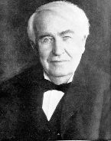 | Feb 15  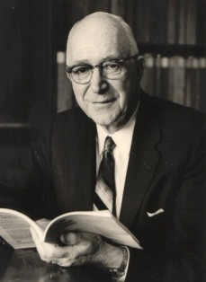  Feb 18 | Part 7: Multiplying Effectiveness  - View attend Tutorial #10 (Chapter 14 – 11:17 minutes) – video skit optional  - Read text—Chapter 14: Effective Delegation and How to Assign Work  - Read the biography of Thomas Edison  - See especially Person-Position Fit, page 329  Part 7 Continued:  - View attend Tutorial #11 (Chapter 15 – 46:30) – video skit optional  - Read text—Chapter 15: The Role of Personality  - Read the biography of Gordon Allport  - See especially The Importance of Self-Concept and Personality Plays a Part, pages 341 - 345  - Complete Interpersonal Styles Questionnaire – assessment (text), page 346  - View Loyalty in The Workplace video online  - Complete Reflection Points on page 368 - 369
 | Feb 20 | 3rd Quarter Exam (Part 6 and Part 7)
 | Feb 22  Feb 25 | Part 8: Developing Others  - View attend tutorial #12 (Chapter 16 – 31:21 minutes) – video skit optional  - Read text—Chapter 16: The Leader as Coach  - Read biography of John Gardner  - See especially The Development of Others, pages 374 – 378, and Developing Leaders, pages 383 - 387  - See especially How to Attract and Keep Good People, pages 388 - 389  - View Pygmalion in Management video online  - View Stay Hungry, Stay Foolish video online  - View The Benefits of Failure video online  - View Keynote Speaker: Marcus Buckingham (Presented by SPEAK Inc. 9:51)  Part 8 Continued:  - View attend Tutorial #13 (Chapter 17 – 26:51 minutes) – video skit optional  - Read text—Chapter 17: Helping People Through Change and Burnout Prevention  - Read biography of John Kotter  - See especially Managing People through Change pages 394 - 396  - View Managing People Through Change video online  - View attend Tutorial #14 (Chapter 17 continued – 35:50 minutes) – video skit optional  - Complete Characteristics of a Hardy Personality – assessment (text), page 427  - See especially – Developing Resilience, pages 431 - 435  - Complete Reflection Points on pages 437 - 438  - View: Celebrate What’s Right with the World (Dewitt Jones: TED x Southwest Tahoe 18:10 minutes)  - View What Makes a Good Life (Robert Waldinger: TED Talk 18 minutes)

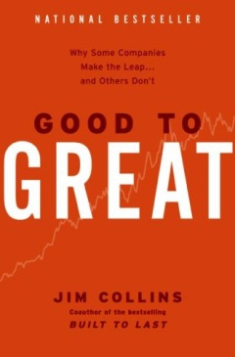 | Feb 27  Feb  29 | Part 9: Performance Management  - Read bibliography of Ken Blanchard  - See especially Performance Management Strategies, pages 454 – 455  - See especially Organizational Performance and Organizational Success, pages 476 - 480  - View attend Tutorial #15 (Chapters 18, 19, and 20 – 50:40 minutes) – video skit optional  - Read text—Chapter 18: Managing Performance  - View Ken Blanchard video online  - View Stairway to Heaven online  - Submit 1 page reaction paper #7 including personal and/or organizational applications of goal setting, coaching to succeed, and correcting performance Due Feb 29  Part 9 Continued:  Read text—Chapter 19: Professional Performance and Sustaining Discipline  - Read the biography of Jim Collins  - Complete the Performance Pyramid – assessment (text) page 460  - See especially Five Levels of Performance Excellence and Organizational Performance, pages 474 - 476  - Performance Pyramid and the Productive Workplace  - View Dancing video online  - View Disney video online  - View McDonald’s video online  - View The Fence That Me and Shorty Built video online  - Complete Reflection Points on pages 489 - 490  - Read text—Chapter 20: The Road Ahead—Challenge and Charge  - Read the biography of Abraham Lincoln  - See especially Nine Keys of Leadership Success, pages 492 - 500  - See especially Going Forward, pages 500 - 501
 | Mar 1 | 4th Quarter Exam (Part 8, Part 9, and Conclusion)
 | Mar 1 | - Last Day of Class  Note: Use online course evaluation procedure at http://eval.nku.edu
 | Mar 5 | Grades due by 9:00 AM

“Education is not the filling of a pail, but the lighting of a fire”
William Butler Yates
Bibliography

Once I had a student ask me for all the books that influenced or shaped me. So, I started building this list. These books are not required for this class, but are available to help inform and open new lines of thought.

A Business and its Beliefs by Thomas J. Watson
Respect for the individual, customer service, and performance excellence

A Child Called It by David Peltzer
About indescribable abuse

A Gentleman in Moscow by Amor Towles
30 years of house arrest in Russian history

A Little History of the World by E.H. Gombrich
Engaging tale of human history

A Man Called Ove by Fredrik Backman
For the curmudgeon in your life

A Short History of Nearly Everything by Bill Bryson
Highly interesting science book

A Walk in the Woods by Bill Bryson
Walking the Appalachian Trail

Albion’s Seed by David Hackett Fischer
British folkways that have shaped America

All Over but the Shoutin' by Rick Bragg
Authentic account of dysfunction and grace

All the Light We Cannot See by Anthony Doerr
An enchanting mix of history, character and story masterfully written

Being Mortal by Atul Gawande
End of life matters

Cinnamon and Gunpowder by Eli Brown
Pirates, food and adventure on the high seas

Code Girls by Liza Mundy
American women code breakers in World War II

Complications by Atul Gawande
Medicine today from a surgeon’s perspective

Cutting for Stone by Abraham Verghese
Politics, medicine, and human relationships intricately told

Economics by Paul Samuelson
Classic text on the principles of economics

Eight Habits of the Heart by Clifton L. Taulbert
Growing up in the south

Einstein by Walter Isaacson
The science and psychology of a genius

Emotional Intelligence by Daniel Goleman
Practical wisdom

Evicted by Mathew Desmond
Without a home, everything falls apart

Execution by Larry Bossidy and Ram Charan
Getting things done

First Things First by Stephen R. Covey
Effective time management

First, Break All the Rules by Marcus Buckingham and Kurt Coffman
Professional Development

Folkways by William Graham Sumner
A study of mores, customs and manners in man’s struggle for survival

Fraternity by Diane Brady
True story about opportunity, courage, growth and love

Gift from the Sea by Anne Morrow Lindbergh
About reflection, learning and tranquility

Good to Great by James Collins
Level 5 leadership, the right people on the bus, the hedgehog concept

Guns, Germs and Steel by Jared Diamond
The biological and cultural evolution of human beings

Hatchet by Gary Paulsen
A boy’s wilderness survival story

Hillbilly Elegy by J.D. Vance
First person sociology book of Appalachian culture

History of Western Philosophy by Bertrand Russell
Highly recommended history of philosophical thought

How Doctors Think by Jerome Groopman
Avoiding health care mistakes

How Starbucks Saved My Life by Michael Gill
Life, work, and the Starbucks experience

How the Irish Saved Civilization by Thomas Cahill
Ireland’s heroic role

How to Win Friends and Influence People by Dale Carnegie
Simple truths for positive relationships

How We Die by Sherwin Nuland
A compassionate reflection on life’s final chapter

If You Meet the Buddha on the Road, Kill Him! by Sheldon Kopp
Self-understanding and personal growth

In Search of Excellence by Tom Peters and Bob Waterman
Business lessons from great companies

Intellectuals by Paul Johnson
The enlightened ideas and different personalities of influential thinkers

In the Heart of the Sea by Nathaniel Philbrick
The true and tragic story of the whaling ship Essex, 1820

Is It Worth Dying For? by Robert S. Eliot
Life in perspective

Leading at a Higher Level by Ken Blanchard
Leadership principles and skills

Learned Optimism by Martin Seligman
The importance of attitude

Make Your Bed by William McRaven
Leadership lessons to change the world

Man’s Search for Meaning by Viktor E. Frankl
Psychology of the concentration camp

Motivation and Personality by Abraham Maslow
The hierarchy of human needs

Nickel and Dimed (2011) by Barbara Ehrenreich
Realistic account of life in low-waged America

Night by Elie Wiesel
Survival and hope

Nothing But the Truth by Avi
The “communication” book all students, parents, teachers and administrators should read

Now, Discover Your Strengths by Marcus Buckingham and Donald Clifton
Professional growth

Oh, The Places You’ll Go! by Dr. Seuss
A book about choice, judgment, consequences and hope

On Becoming a Person by Carl Rogers
Guidance for psychological health

On Writing by Stephen King
A memoir of the craft

Plato, Not Prozac! by Lou Marinoff
Right thinking, right living

Quiet by Susan Cain
Examination and discussion of introversion and extroversion

Riders of the Purple Sage by Zane Gray
Cattle rustling, nature’s beauty, religion, prejudice, and cowboy love in the American west

Sabbath by Wayne Muller
Work well, rest well

Sailing the Wine-Dark Sea by Thomas Cahill
The role of the Greeks in western civilization

Sapiens: A Brief History of Humankind by Yuval Noah Harari
“Must read” history of humankind

Season of Life by Jeffrey Marx
About turning boys into men

Soul Pancake by Rainn Wilson
Thought provoking questions that should be discussed by partners

Sutton by J. R. Moehringer
Unique character and gangster history

Team of Rivals by Doris Kearns Goodwin
Early American leadership

Ten Commandments for Business Failure by Donald Keough
Business wisdom based on true-life cases

That Dark and Bloody River by Allan Eckert
Historical account of the Ohio River Valley from 1764 to the early 1800s

The 7 Habits of Highly Effective People by Stephen Covey
Timeless principles that build character

The Art of Loving by Erich Fromm
Meaningful relationships

The Bible (Old and New Testament)
Basis of the religious beliefs and moral truths of Christianity

The Blank Slate by Steven Pinker
Human nature based on science and common sense

The Cave and The Light by Arthur Herman
The influence of Plato and Aristotle on western civilization

The Checklist Manifesto by Atul Gawande
How to get things right in a complex world—from medicine to aviation to construction to
finance

The Defining Decade by Meg Jay
Read before you are thirty

The Devil in the White City by Erik Larson
Madness and magic, stranger than fiction

The Dream Manager by Matthew Kelly
Employee morale, retention and performance

The Effective Executive by Peter Drucker
A handbook for doing the right things with contribution as the measure of success

The Emperor of All Maladies by Siddhartha Mukherjee
The history and biology of cancer

The Five Dysfunctions of a Team by Patrick M. Lencioni
Work team dynamics

The Five People You Meet in Heaven by Mitch Albom
The purpose and importance of people in our lives

The Gene by Siddartha Mukherjee
A personal and scientific history

The Goldfinch: A Novel by Donna Tartt
A story of art, intrigue, love and loss

The Greatest Generation by Tom Brokaw
Responsibility, bravery, sacrifice, and hard work of the World War II generation

The Greatest Salesman in the World by Og Mandino
About attitude and service

The Happiness Project by Gretchen Rubin
A contemporary and compelling account of the pursuit of happiness

The Iliad and The Odyssey by Homer
Distillation of the moral philosophy of ancient Greece

The Killer Angels by Michael Shaara
Leadership challenge and courage

The Last Lecture by Randy Pausch
Lessons from a young life too soon gone

The Leader’s Bookshelf by James Stavridis
Books that have shaped America’s military leaders

The Life of Pi by Yann Martel
Survival at sea with a 450-lb Bengal tiger

The Little Prince by Antoine de Saint-Exupery
A children’s (adult) book about purpose, responsibility and love

The Martian by Andy Weir
Science and survival, unvarnished page-turner

The Next 100 Years by George Friedman
Social, economic and military forecast

The One Minute Manager by Kenneth Blanchard
The fundamentals of performance management creatively taught

The People’s House by David Pepper
Political thriller

The Practice of Management by Peter Drucker
The responsibilities and fundamental tasks of management

The President’s Club by Nancy Gibbs and Michael Duffy
The personalities and relationships of American presidents

The Principles of Scientific Management by Frederick Taylor
The seminal management book on work productivity

The Prophet by Kahlil Gibran
Timeless wisdom

The Reckoning by David Halberstam
The fall and rise of quality in the automobile industry

The Richest Man in Babylon by George Clason
The best financial advice you will ever receive

The Righteous Mind by Jonathan Haidt
The pervasive power of rationalization

The Road Less Traveled by Scott Peck
Responsibility, discipline and love

The Screwtape Letters by C.S. Lewis
Human nature

The Servant by James Hunter
A coaching book for developing leaders

The Storm of War by Andrew Roberts
Definitive history of the second world war that claimed the lives of 50 million people

The Traveler’s Gift by Andy Andrews
Decisions that Determine Personal Success

The Warmth of Other Suns by Isabel Wilkerson
The epic story of America’s great migration

The Worldly Philosophers by Robert Heilbroner
The lives, times and ideas of the great economic thinkers

Toward a Psychology of Being by Abraham Maslow
The human potential for psychological growth

Turn the Ship Around! by David Marquet
How to take your team from last place to best in class

Uncle Tom’s Cabin by Harriet Beecher Stowe
A folk picture of an age and a nation

Uncommon Friends by James Newton
A lifetime of friendship with Thomas Edison, Henry Ford, Harvey Firestone, Alexis
Carrel and Charles Lindberg

Washington: A Life by Ron Chernow
A "must read" biography for every American

Who Says Elephants Can’t Dance? by Louis Gerstner
An instructive book on business leadership

Wooden on Leadership by John Wooden
Principles and practices

Work Rules! by Laszlo Bock
Google policies and practices based on empirical data

World Order by Henry Kissinger
Past, present and future of the geopolitical world

Younger Next Year by Chris Crowley and Henry S. Lodge
The biology and sociology of aging

Spring, 2019

