STEM: without Mathematics, it’s just STE!
Andy Long, NKU Dept. of Mathematics and Statistics; GEAR UP, March, 2013
longa@nku.edu

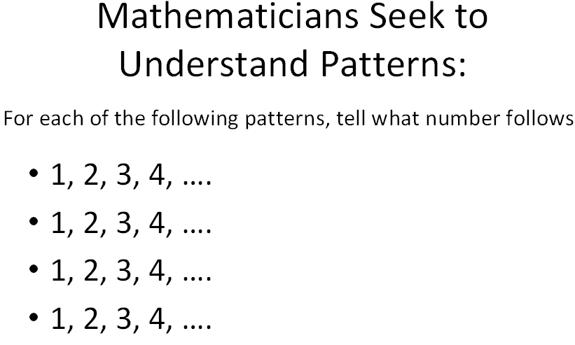 (It can be kind of tricky, can’t it! Mathematicians do their best, but may not know if they’re right….)

More familiar (and/or popular and/or important) patterns:

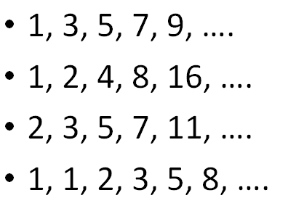
What’s next in this geometric pattern?



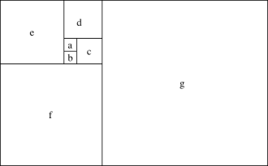 ← How about in this geometric pattern?

