Felicia Fleming

Math Man Logo

My “Math Man” logo is a perfect blend of both my personal life mottos and some of my favorite math related topics and symbols. For starters, his face is made up of two parentheses. When working an algebraic equation, you always solve what is inside the parenthesis first. In life I have learned that you must put yourself first in order to help others. I am a huge advocate for volunteering and helping others but I know that unless I take care of myself I can’t help take care of others. His hair is actually made up of a positive correlation. I am a firm believer of looking for the positives in even the worst or situations.

In the middle of his forehead is a crinkle and his eye brows made up of the Pi symbol. I have always been fascinated with Pi and it’s never ending number. Also, I am 7 months pregnant and LOVE pie so I found this fitting in my life. His eyes are made up of an infinity sign with a multiplication and addition sign for pupils. I was raised to always multiply and add to everything you receive in life. The infinity sign fascinates me because it truly shows what it represents, continuing on forever. You can just draw the symbol and understand that it means there is no ending, which I find neat. And I do believe that our souls do live on forever even after they have left our physical presence.

The eyes and picture themselves are also never ending because they are a fractal. Fractals appear in nature, like Fibonacci’s spirals and I love nature. I am an outdoorsman for sure! If you continue down the face you will notice a cinquefoil knot for lips. My Mother always told me “if you have nothing nice to say, say nothing at all”. So I honor this by keeping my lips sealed unless I am spreading love. In class I loved learning about how links can create unbreakable bonds, which is how I try to form my friendships. Obviously, he’s very colorful because so am I! No dull days, make your own sunshine!

Original image

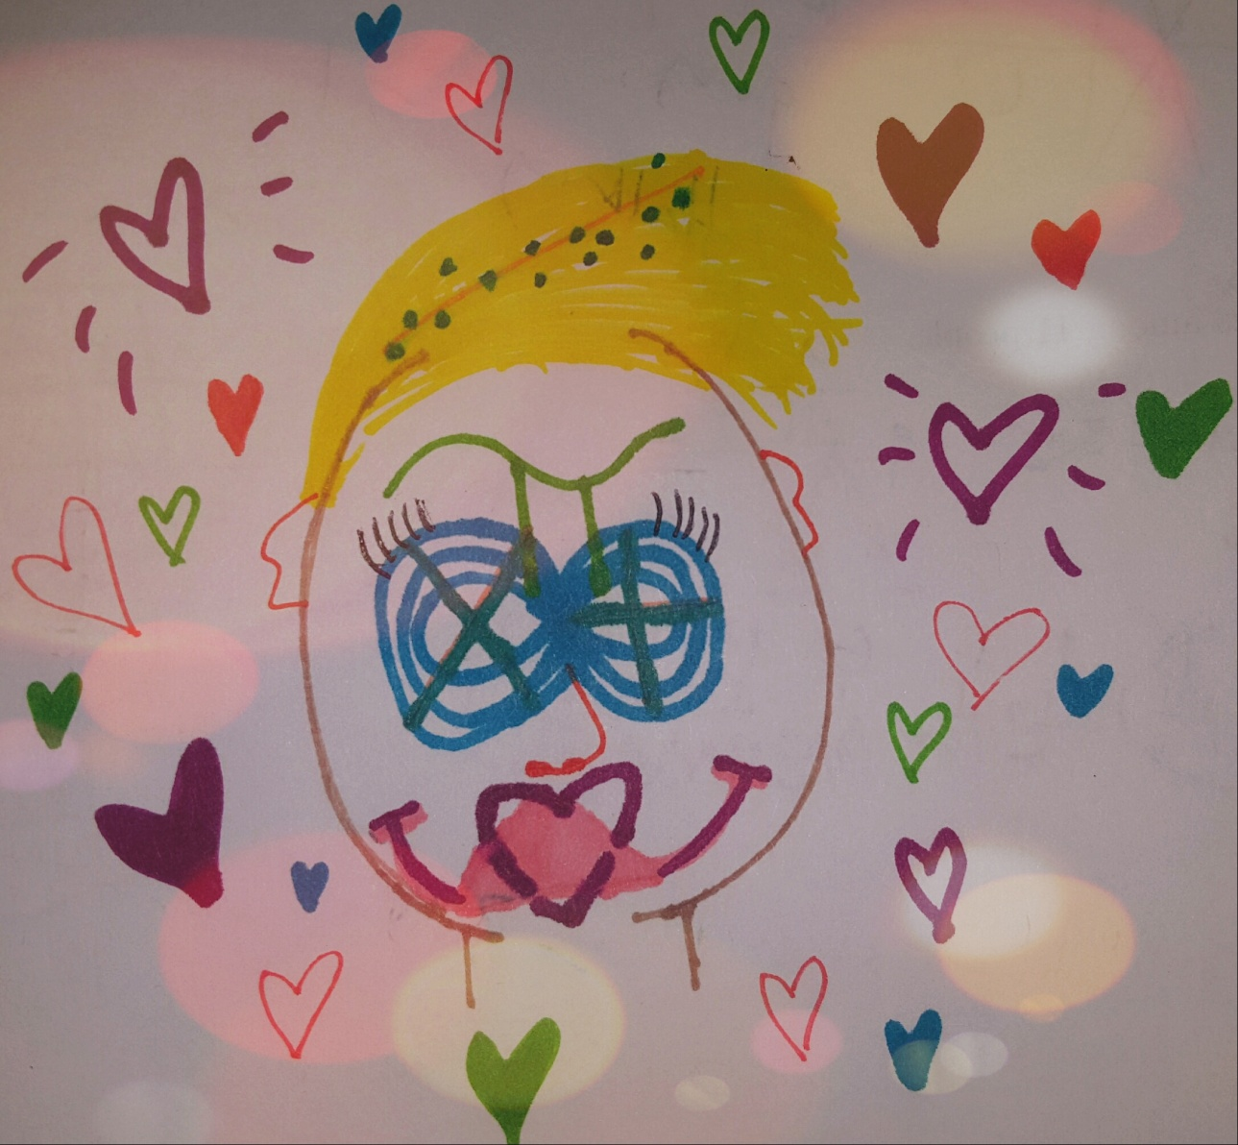

**Final image!**

