**SIR Lab III**

**Covid-19 in Italy**

Flow rates out of the Infectious population:

To dead: (1-[Surviving rate])*[Infectious]

To recovered, or recovering: [Surviving rate]*[Infectious]

A. 4

a: Simulation for 37 days (until the 9th of April).

b: How many Total cases are expected on the 9th of April?

Answer: 29746 cases

c: How many deaths are expected on the 9th of April?

Answer: 2023 deaths

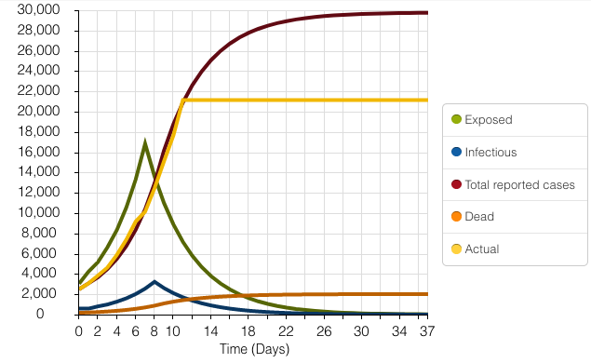

5. Obviously they’re not doing very well, since there are 143K or so cases, and 28K deaths or so. So they did a good job of fitting the early data, but it didn’t “turn over” as they indicated they thought that it might.

B. 1. Simulate, and include this in your report. Describe what is going on.

As one can see, the new data doesn’t do at all what they had projected. It’s soaring off to the 100K range. And that’s after only 28 days. 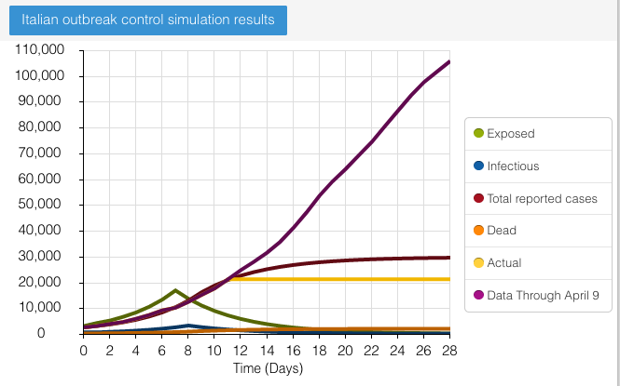

If we extend that to 37 days, we see this:

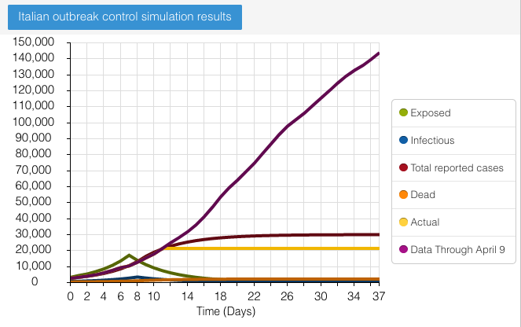

B. 2. So, having made the changes, I simulate and get

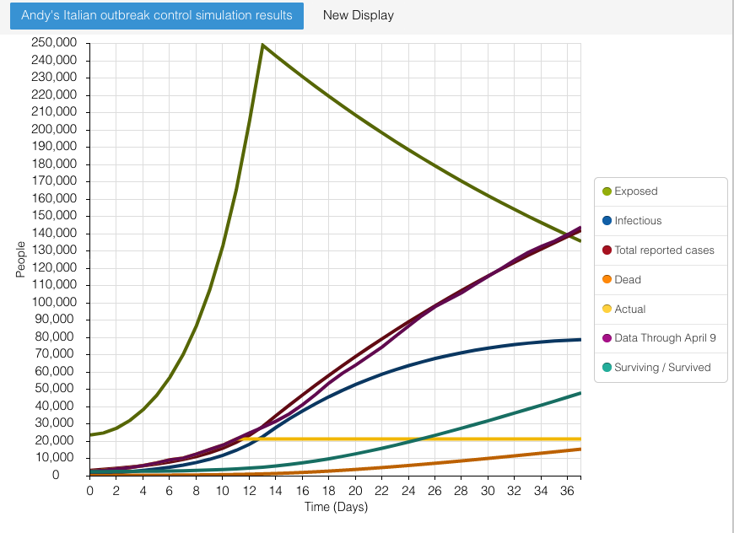

this graph.

It does a good job of estimating total cases; in terms of deaths and recovered, it has 15,232 deaths, and 47,791 recovered. Target was 18,279 deaths, and 28,470 recovered.

Our “recovered” may not have been what the Italians are counting, however. They have “Surviving/Survived” as a category; I’m including Infectious in that now, too.

B. 3. Extend the simulation from the 9th of 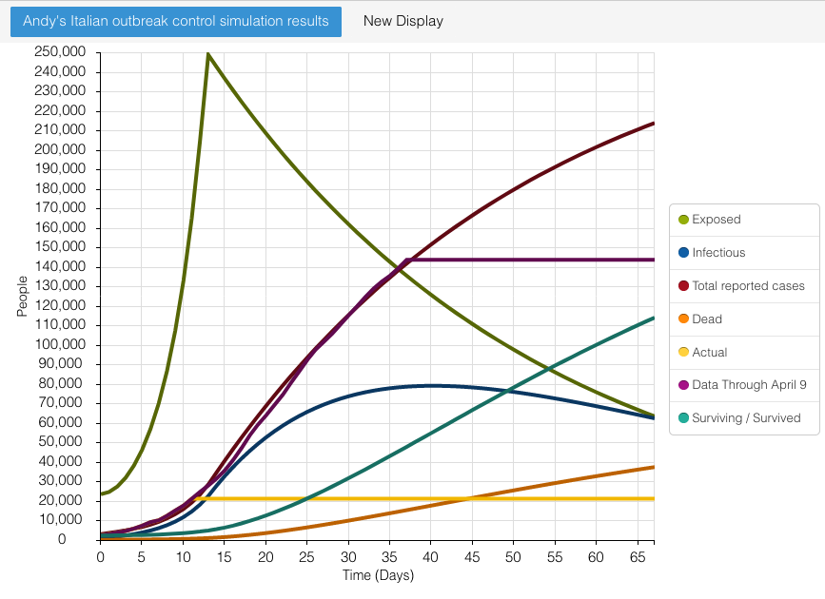April to the 9th of May.

1. Include your model graph.

b• What would you predict for Total cases, deaths, and infecteds on the 9th of May?

* 1. Total cases: 214K
  2. Deaths: 37.4K
  3. Infectious: 62.4K

c• It is the sum of the recoveryrate and deathrate that determines how much "attrition" the infected population suffers. Can you "tune" these parameters to get the Dead and the Recovered to fall more in line with the data for their status as of April 9th?

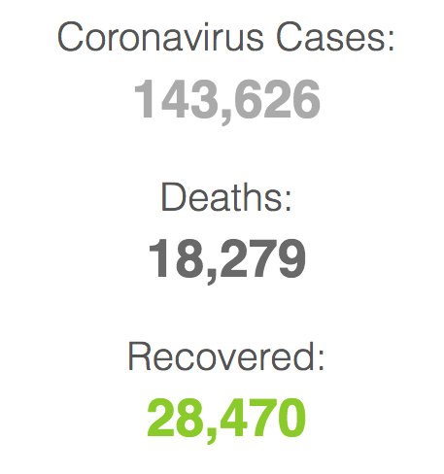

I’ve got deaths to 18353 with a deathrate of 0.012, and recoveryrate of 0.028 (they still sum to .04, so nothing else changed in the model). But the recovereds are at 44,760. So a little closer.

Silas and I worked together and dropped the death rate to 0.008 and the recovery rate to 0.015, and that got the dead and recovered pretty darned close (without costing us too much on the total case match).

C. Comment in your report on what was changed from the original Italian model. When the parameters of the model are changed -- or when the model undergoes surgery, as what happened here -- you want to ask "Is the model better?" "Does it do a more realistic job of modeling the situation?" Those kinds of things.

I’ve already mentioned a few things:

• I moved the date of the first lockdown up a day. If you look into that, you'll see that there's a little wiggle-room in that (check [Wikipedia](https://en.wikipedia.org/wiki/2020_Italy_coronavirus_lockdown#Nationwide_expansion) -- Italian for "Web Encyclopedia" -- on that). But I think that I'm early....

• I added the "Infectious" to the "Total reported cases". In the first model, as soon as the Infectious were in the model for a day, they were divided into "Surviving/Survived" and "Dead" - because they'd been identified as problematic, and stopped by the authorities from further infecting people. I kept them in, still infecting people (partly because they infect those in nursing homes, hospitals, their families, etc. -- in fact, they could be the most dangerous infectors!),

But an alternative would have been to make the Exposed do much of the infecting, while asymptomatic; and calling the infectious "Symptomatic" -- and hence quickly removed (yet still dangerous, and still infectious).

So in addition I might add that I don't like the ratio of recovery to death: to capture the data, and to get the dead right, we have a ratio of recovery to death of .028/.012 -- which says that you have a third dying. That's way too high!

So what's going on is that we're not dealing with true numbers. There are a lot asymptomatic people, some of whom may actually also be infectious. They will never be counted, because they won't be "caught" (until we've developed a test for those who've had the disease without knowing it).

They had an incubation rate of .192, and I've got it at .025. What this means is that I've really put the breaks on incubation -- that the exposed move to infectious much more slowly than before. It seems unrealistically slow: I've heard in reports that it's maybe just a few days from exposure to symptoms; on the other hand, we ask someone to wait 14 days in quarantine to be sure that they're not going to express the disease (symptoms). I think that their's is more realistic.

We've kept the same R0, and I've left the initial popultions in place. So there shouldn't be any problems there.

I think that the way I've implemented the Total Lockdown is a lot more realistic than the way they did. There will be "leakage", so our model here leaks -- but tightens over time.