Alyssa Farmer and Maria McMahon

Dr. Long

Mat 375

16 February 2018

Mini Project 2

Sokode is the second largest city in Togo with approximately 113,000 citizens. Sokode sits midway between the ocean and the Sahel strip with average elevation of 1115 feet or 340 meters. The climate is tropical with an average of 1346 mm of rainfall each year. There are two seasons, with rainy season lasting from April to October and dry season lasting from November to March. During the months of January and February temperatures average around 99 degrees Fahrenheit. Using the monthly data given we are going to further study the possible rise in temperature.

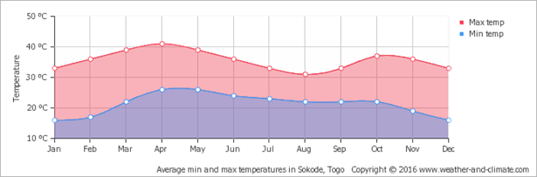

After comparing the monthly averages to the annual averages from the first data set we verify the initial data given is correct. There were no maximum or minimum outliers to suggest errors in the collection of the temperature data.

Minima:

The plot of the monthly minimum temperatures can be seen below. The temperatures appear to be rising and oscillate each year, but we will need to fit models that provide evidence of this.

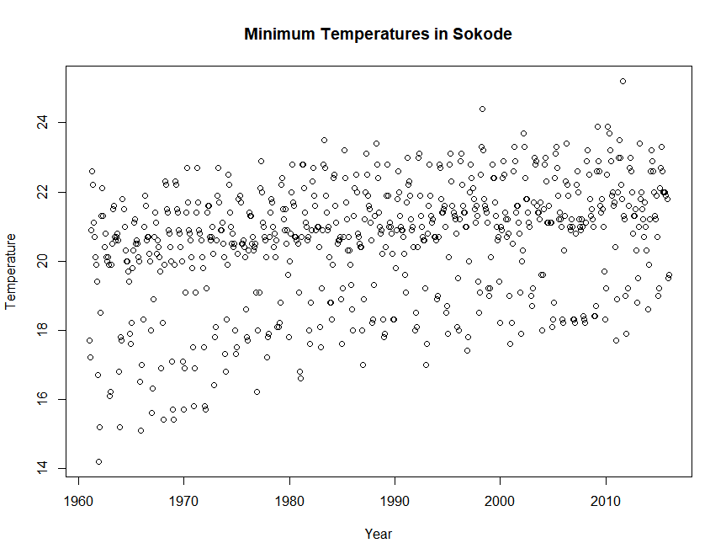

A linear model was fit first with sine and cosine terms to account for oscillations due to the monthly data being added in. The linear and sinusoidal terms all ended up being significant, and the confidence intervals for their parameters do not contain zero, so the terms should be kept. The residuals are random, scattered, and have constant variance, so there should not be any issues with normality.

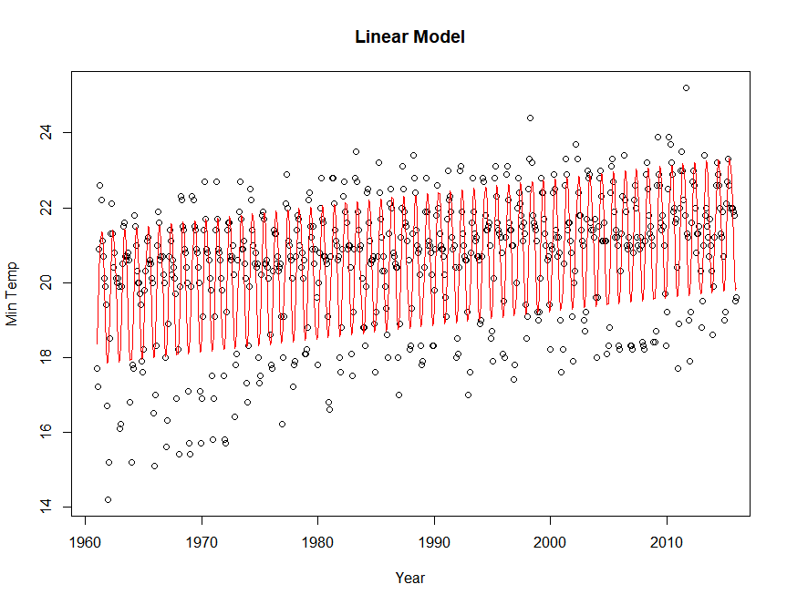

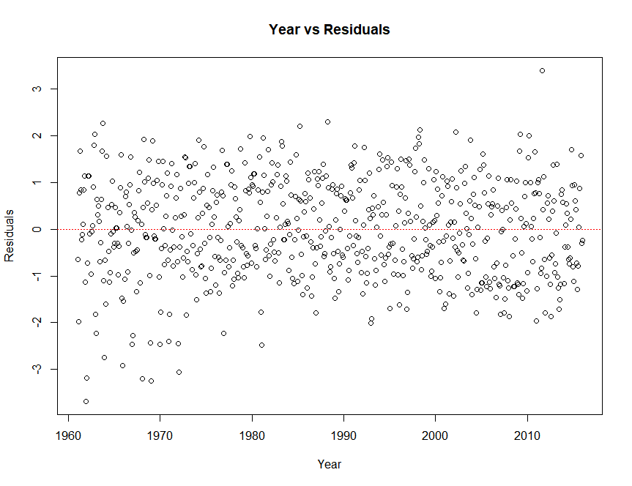

Coefficients:

|  |  |  |  |  |
| --- | --- | --- | --- | --- |
|  | Estimate | Std Error | T-Value | P-Value |
| Intercept | -51.721507 | 5.153107 | -10.04 | <2e-16 |
| year | 0.036357 | 0.002591 | 14.03 | <2e-16 |
| Sin(2*pi*year) | 0.973782 | 0.058186 | 16.74 | <2e-16 |
| Cos(2*pi*year) | -1.531583 | 0.058186 | -26.32 | <2e-16 |

---

Residual standard error: 1.057 on 656 degrees of freedom

Multiple R-squared: 0.6394, Adjusted R-squared: 0.6378

F-statistic: 387.8 on 3 and 656 DF, p-value: < 2.2e-16

|  |  |  |
| --- | --- | --- |
|  | 2.5% | 97.5% |
| Intercept | -61.8400808 | -41.60293369 |
| year | 0.0312690 | 0.04144577 |
| Sin(2*pi*year) | 0.8595297 | 1.08803507 |
| Cos(2*pi*year) | -1.6458238 | -1.41734193 |

A quadratic model was fit next to see if anything additional could be added to the model. The quadratic term is significant, so it should be kept in as well. Again, there are no issues with the residuals.

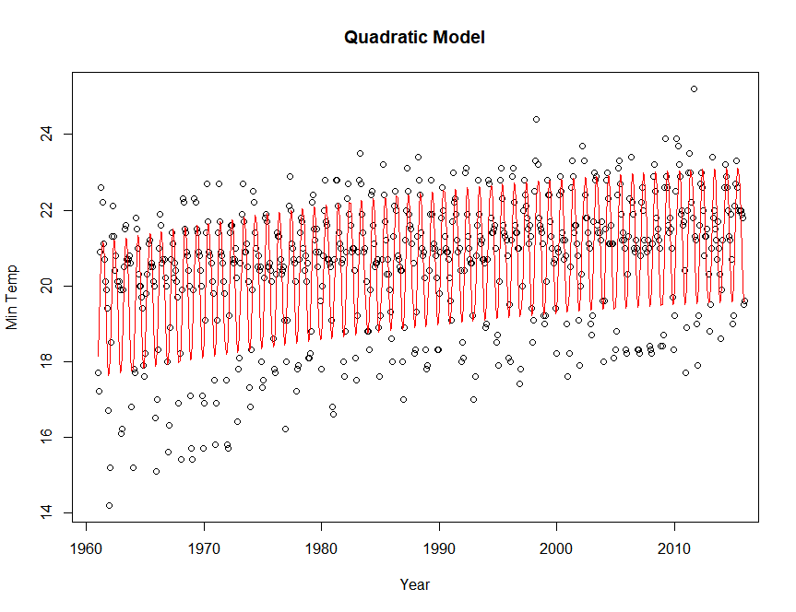

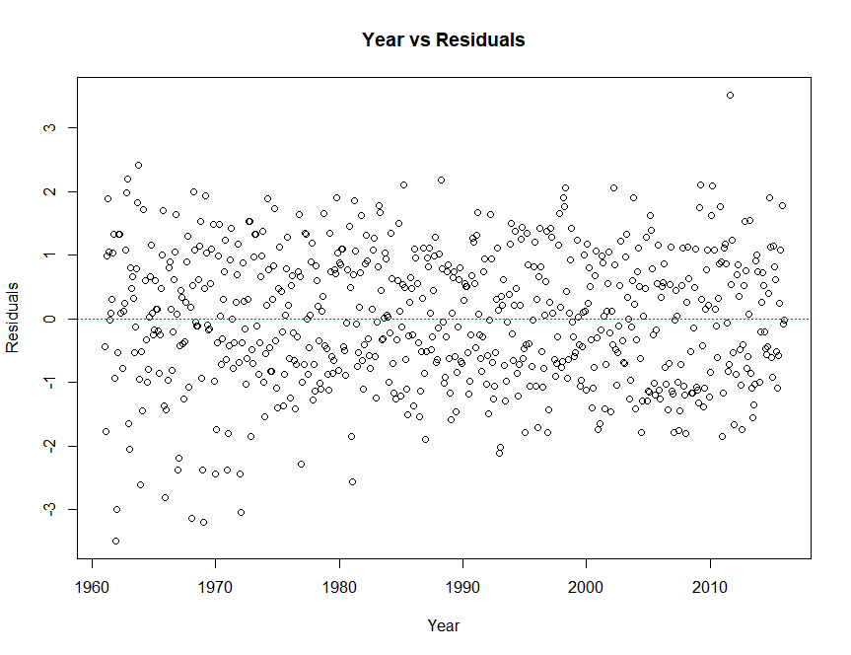

Coefficients:

|  |  |  |  |  |
| --- | --- | --- | --- | --- |
|  | Estimate | Std. Error | T-Value | P value |
| Intercept | -1.756e+3 | 7.189e+2 | -2.455 | 0.0143 |
| year | 1.760e | 7.231e^-1 | 2.434 | 0.0152 |
| I(year^2) | -4.333e-4 | 1.818e-4 | -2.383 | 0.0174 |
| Sin(2*pi*year) | 9378e-1 | 5.798e-2 | 16.795 | <2e-16 |
| Cos(2*pi*year) | -1.532e | 5.797e-2 | -26.418 | <2e-16 |

---

Residual standard error: 1.053 on 655 degrees of freedom

Multiple R-squared: 0.6425, Adjusted R-squared: 0.6403

F-statistic: 294.3 on 4 and 655 DF, p-value: < 2.2e-16

|  |  |  |
| --- | --- | --- |
|  | 2.5% | 97.5% |
| Intercept | -3.176730e+3 | -3.535279e+2 |
| year | 3.399557e-1 | 3.179612e+00 |
| I(year^2) | -7.903560e-04 | -7.634080e-05 |
| Sin(2*pi*year) | 8.599349e-01 | 1.087630e+00 |
| Cos(2*pi*year) | -1.645375e+00 | -1.417704e+00 |

From the results of the linear and quadratic models we concluded that the relationship between years and rise in temperature is significant. A cubic model was also performed, but the results were insignificant. This positive relationship suggests that as time goes on the annual minimum temperature is increasing.

Maxima:

A plot of the maximum temperatures is shown below. The temperatures do seem to be increasing, but it is less obvious than it was for the minimum temperatures. Models will be performed to test the significance of this increase.

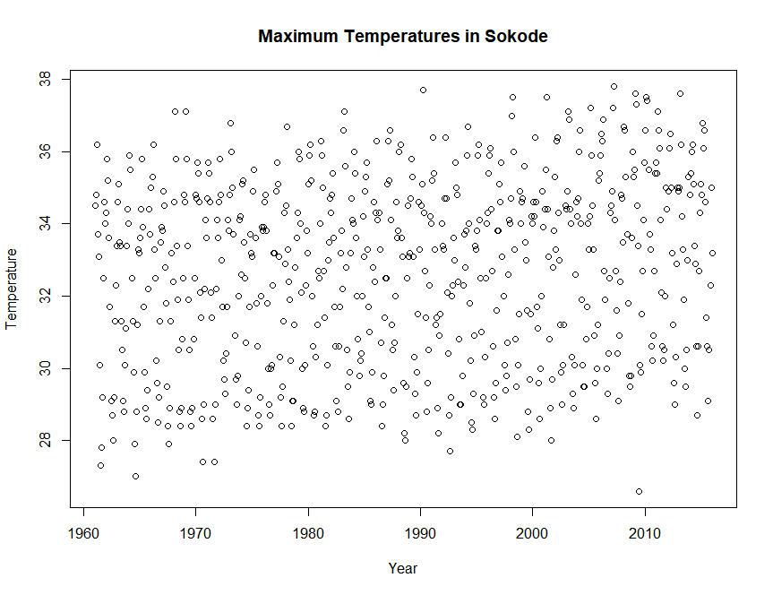

Again, a linear model was performed first with sine and cosine terms added in to account for oscillations in the monthly data. Each term was significant, with their parameters not containing zero, so all of the terms should be kept.

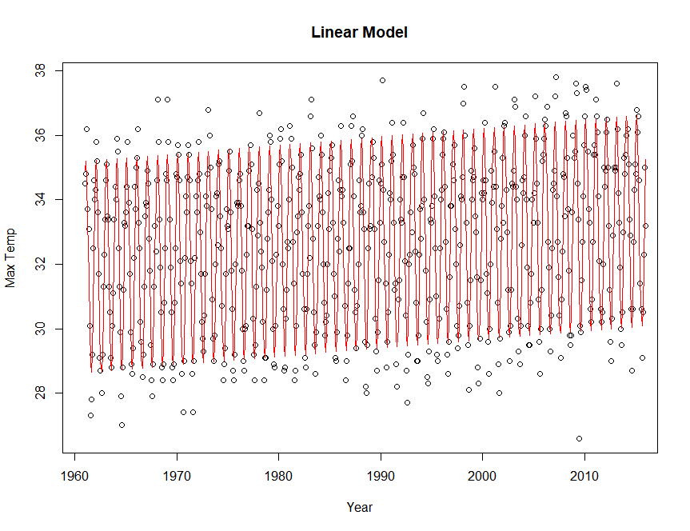

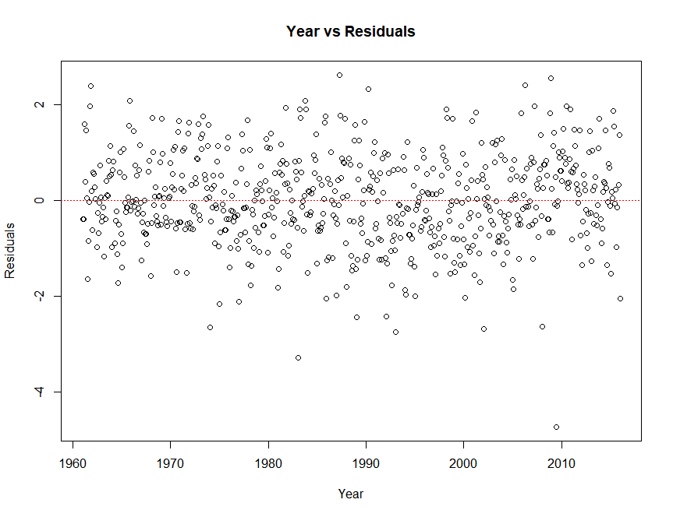

Coefficients:

|  |  |  |  |  |
| --- | --- | --- | --- | --- |
|  | Estimate | Std Error | T-value | P-value |
| Intercept | -19.923542 | 4.617191 | -4.315 | 1.84e-05 |
| year | 0.026433 | 0.002322 | 11.384 | < 2e-16 |
| Sin(2*pi*year) | 2.118648 | 0.052134 | 40.638 | < 2e-16 |
| Cos(2*pi*year) | 2.517314 | 0.052129 | 48.290 | < 2e-16 |

Signif. codes: 0 ‘***’ 0.001 ‘**’ 0.01 ‘*’ 0.05 ‘.’ 0.1 ‘ ’ 1

Residual standard error: 0.947 on 656 degrees of freedom

Multiple R-squared: 0.8621, Adjusted R-squared: 0.8614

F-statistic: 1367 on 3 and 656 DF, p-value: < 2.2e-16

|  |  |  |
| --- | --- | --- |
|  | 2.5% | 97.5% |
| Intercept | -28.98979713 | -10.8572869 |
| year | 0.02187358 | 0.03099197 |
| Sin(2*pi*year) | 2.01627774 | 2.22101884 |
| Cos(2*pi*year) | 2.41495416 | 2.61967417 |

A quadratic model was fit again to see if there is significant improvement in the model. The quadratic term is significant, so it should be kept in. Again, there are no issues with the residuals.

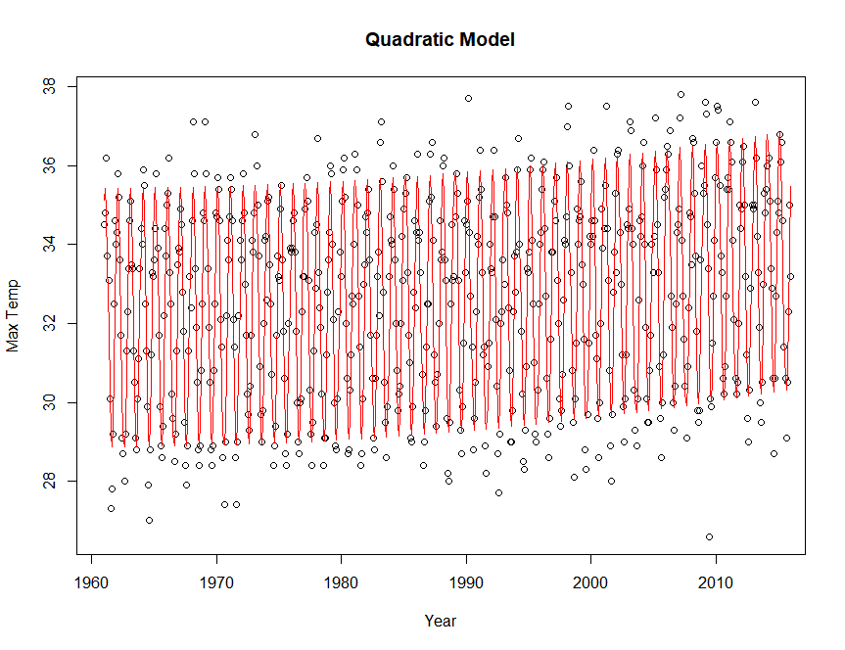

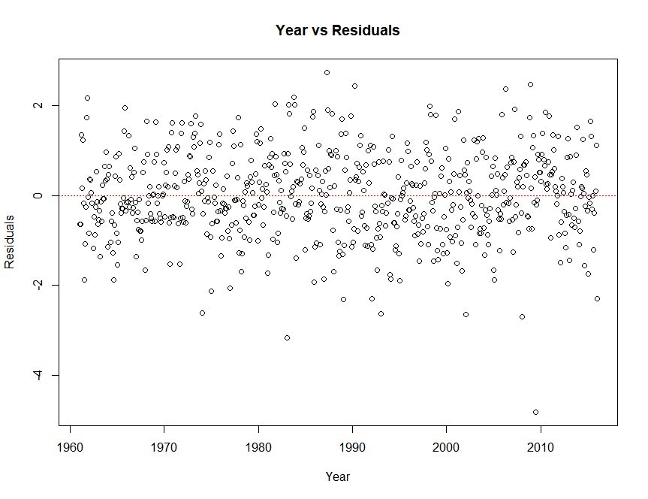

Coefficients:

|  |  |  |  |  |
| --- | --- | --- | --- | --- |
|  | Estimate | Std. Error | T-value | P-value |
| Intercept | 1.897e+03 | 6.426e+02 | 2.953 | 0.00326 |
| year | -1.902e+00 | 6.463e-01 | -2.943 | 0.00336 |
| I(year^2) | 4.849e-04 | 1.625e-04 | 2.984 | 0.00295 |
| Sin(2*pi*year) | 2.119e+00 | 5.182e-02 | 40.882 | < 2e-16 |
| Cos(2*pi*year) | 2.517e+00 | 5.182e-02 | 48.579 | < 2e-16 |

---

Residual standard error: 0.9413 on 655 degrees of freedom

Multiple R-squared: 0.8639, Adjusted R-squared: 0.8631

F-statistic: 1040 on 4 and 655 DF, p-value: < 2.2e-16

|  |  |  |
| --- | --- | --- |
|  | 2.5% | 97.5% |
| Intercept | 6.357661e+02 | 3.159210e+03 |
| Year | -3.171266e+00 | -6.331152e-01 |
| I(year^2) | 1.658426e-04 | 8.040459e-04 |
| Sin(2*pi*year) | 2.016889e+00 | 2.220408e+00 |
| Cos(2*pi*year) | 2.415517e+00 | 2.619015e+00 |

From the results of the linear and quadratic model there appears to be a significant relationship between years and average temperature. This positive linear relationship indicates that as time passes average maximum temperature increases. The linear and quadratic models had r-squared values above 0.85 suggesting they were good fits for the monthly data. We also performed a cubic model, but the results proved to be insignificant.

Conclusions

We believe that both average minimum and average maximum temperature are showing significant increases as years pass. Moving forward we would like to get more information from the Togolese meteorologists to help us predict the further rise in temperature. The new data on average rainfall will be useful to help determine other factors that affect the rise in temperature. We are also interested in how the data was collected, was the temperature taken at the same location and same time every day? There are many factors that could skew data if not kept consistent.