Patrick Nielsen

Clayton Frink

Mat 375

**Mini-Project 2: Average Monthly Temperature**

**In Kara, Togo**

The purpose of this report is to interpret temperature data for the Kara region in the country of Togo. The Kara region is in norther Togo and is just north of the Kara river and as of the 2010 cencus has a population of 94,878. To the northeast of Kara lies the Kabyés Mountains these are some factors that could influence the regions climate. The data provided was monthly average temperatures in Celsius beginning January 1977 spanning to December of 2015.

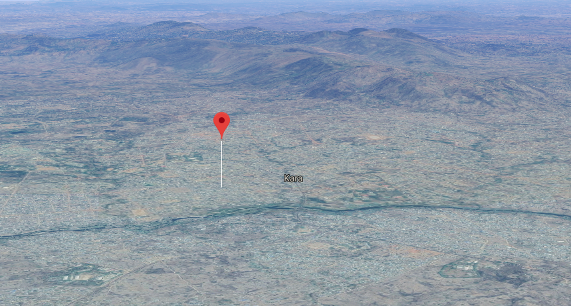

From the previous report on the Kara region written by Matthew Gall, Chris Milesky, and Maria Ruwe it was found that there was significant evidence to conclude that both the maximum and the minimum temperatures were increasing. They determined from their annual average data the best fitted model in representing the temperature in relation to time for the maximum to be a linear equation while the best fitted model for the minimum temperature to be quadratic. Because we had monthly temperatures and did not round any of our data our average temperature over the 39 years differs from the previous report by $0.006672561942458799$ degrees Celsius.

**Yearly Averages**

|  |  |  |  |  |  |  |  |  |  |
| --- | --- | --- | --- | --- | --- | --- | --- | --- | --- |
| **1977** | **1978** | **1979** | **1980** | **1981** | **1982** | **1983** | **1984** | **1985** | **1986** |
| 33.05 | 32.65 | 33.0583 | 33.2592 | 33.4708 | 32.69333 | 33.6872 | 33.4246 | 33.1338 | 33.2636 |
| **1987** | **1988** | **1989** | **1990** | **1991** | **1992** | **1993** | **1994** | **1995** | **1996** |
| 34.3636 | 33.4857 | 33.224 | 33.6751 | 33.1667 | 33.2333 | 33.2264 | 33.5633 | 33.9417 | 34 |
| **1997** | **1998** | **1999** | **2000** | **2001** | **2002** | **2003** | **2004** | **2005** | **2006** |
| 33.5667 | 34.3667 | 33.9083 | 33.925 | 34.5 | 34.1583 | 33.1133 | 33.9358 | 34.0917 | 34.4701 |
| **2007** | **2008** | **2009** | **2010** | **2011** | **2012** | **2013** | **2014** | **2015** |
| 33.9513 | 33.9 | 34.2333 | 34.4917 | 34.7997 | 33.9217 | 33.8281 | 34.2928 | 34.6747 |

When plotting our data we determined an unusual value for the minimum average temperature for May 1991 of 31.3 degrees Celsius. The decision was made to remove the data point so our prediction models would not be pulled toward the outlying data point.

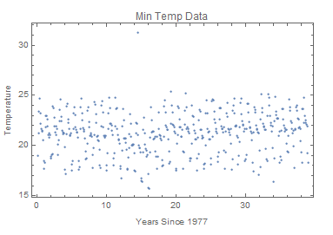

With 95% confidence, there was sufficient evidence to conclude that both the minimum and the maximum temperatures were increasing (as p-values <.05).

**Min**

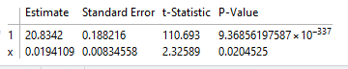

**Max**

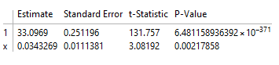

We determined that the best model for interpreting the maximum data would be a linear model with trigonometric sine and cosine terms. When reviewing the quadratic term, we found there was sufficient evidence at the 95% confidence level that the coefficient for the quadratic term was zero; therefore, it was not included in the model.

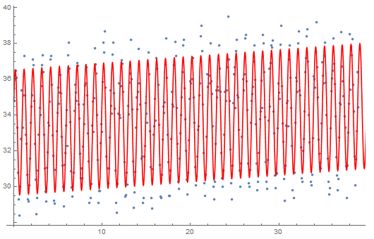

Temperature

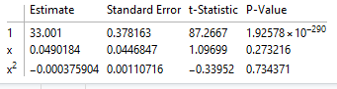Years since 1977

For the minimum data, we decided that the best model for interpretation would be a quadratic model with a linear component, as well as trigonometric sine and cosine terms. When reviewing the model, each piece of our model was found to have enough evidence to be included.

Temperature

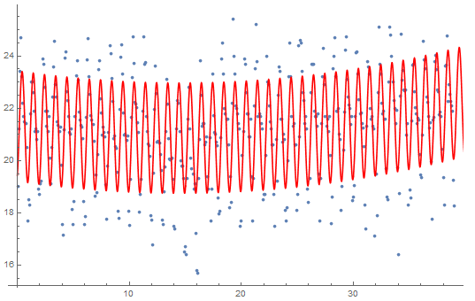Years since 1977

Unfortunately, we were unable to make models that do a better job of considering the probabilistic notion that the temperature tapers off eventually, instead of the accelerating increase found with the current ‘best’ model. When added, the logistic term, the model takes an early dip, which wasn’t seen in the plot of the data values.