Leah Gillespie, Nathan Bergman, Joey Stevens

Dr. Long

MAT 375

January 26, 2018

Mini Project 1: Niamtougou

1. Determine if either of your maximum and minimum temperature time-series demonstrate **significant** increases in temperature over time. Discuss any characteristics of the data that seem relevant.

Only our maximum seemed to show a significant increase in temperature over time. We are using NASA’s definition for significant temperature change which is .5 degree. Our minimum data from Niamtougou was too sporadic to say that there was a significant increase.

1. Provide and discuss your best models Temperature(time) for each of the two time-series.

For our maximum data of Niamtougou we felt the following quadratic was our best model:

Temperature = 32.3381 - 0.0135048 (time) + 0.000440352 (time)2

We were leaning toward this model over the linear equation because we could see some of the data curving upward. Recalling from class that one should not, “fit a line to a banana,”we ruled the linear model out. The below parameter tables are testing our parameters of the linear and quadratic functions on the maximum data. We used the tables to compare the linear and quadratic functions. We wanted to push as many terms on our equation without being excessive. For x3 and higher ,we saw there was a possibility of the coefficients of the polynomial term to be zero. This would mean these terms would be meaningless, since they would equate to zero. Thus, we settled on a quadratic.

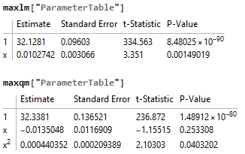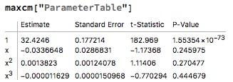

To represent the minimum data of Niamtougou, we went with a trigonometric function:

Temp = 20.9042 + 0.156498 Cos [2.54678 + 0.270306 (time)]

We chose this model because we saw that the data seemed to rise and drop like a sine curve. We quickly ruled out a linear model because the data was too spread out to be represented by just a line. We also ruled out a quadratic or other polynomial because the waves in the data would require a polynomial of an excessive degree. The below parameter table represents the parameters of our cosine model in the form: f(x) = c + (amp)cos(a(x)+b)

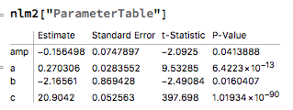

In this table, we were focused on the parameter amp. Since amp is unlikely to be zero, meaning the sine term is significant, our model would be a better fit than a linear equation (shown below).

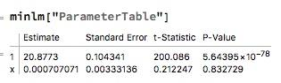

From the above table, we saw that there is a strong possibility of our x parameter being zero, resulting in the term being pointless and the line becoming horizontal. This resulted in us deciding that the linear model would not be a good fit.

1. Provide graphs of the data with their model(s), with labels and title.

32.3381 - 0.0135048x + 0.000440352x2

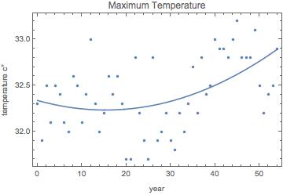

20.9042 - 0.156498 Cos(2.16561 - 0.270306t)

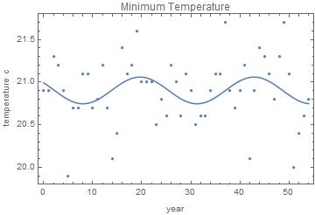

1. Provide graphs of the residuals, with labels and title.

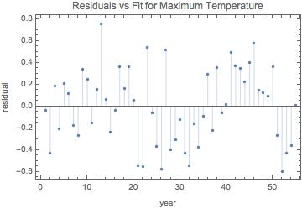

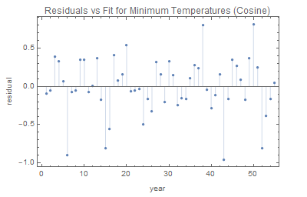

1. Discuss what additional information might be useful moving forward, problems with your data, and any information you'd like to know from the Togolese meteorologists.

Our main problem with the data is that it is not specific at what it is representing. Our group can draw all the conclusions and make all the models we want about the data. However, this would all be pointless because we started with data that we were unsure of. We would press the Togolese meteorologists to be more descriptive in what the minimum and maximum temperatures are representing, so we could be assured at what our models are representing.