Austin Campbell

MAT 375: Applied Mathematical Models

Dr. Long

January 26, 2018

Mini-Project 1: Average Yearly Temperature

Trends in Lomé, Togo

Provided for analysis was data regarding the yearly average high and low temperatures, as measured in the capital city of Lomé, Togo. The data sets start from the year 1961 and continue through 2015. The interpreted meaning of the data is that the daily high and low temperatures were recorded throughout the year in the city of Lomé. Then, each days’ high and low temperature was averaged together to give the yearly high temperature and the yearly low temperature for the city.

The following is the data provided:

**Table** **1**

The data was analyzed as two data sets; average yearly high temperature and average yearly low temperature. To make the model more comprehendible the year was adjusted to start at year 0 and continued to year 54 (55 data points). A linear regression model was undertaken on both sets of data to find an equation in the form of:

$$y\left(x\right)=a+bx$$

Parameters a and b where then calculated for both data sets. The following equation was produced for the average yearly high temperatures:

$$y\left(x\right)=30.2428+0.0339x$$

Figure 1 shows a scatter plot graph of the data set with the linear regression fitted line.

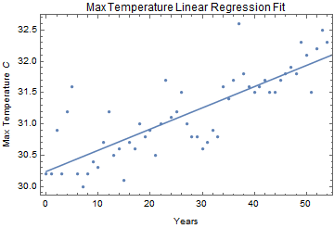**Figure** **1**

Figure 2 shows the residuals from the linear regression fitted line.

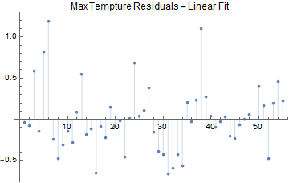**Figure** **2**

The following equation was produced for the yearly low temperatures:

$$y\left(x\right)=22.4573+0.0458x$$

Figure 3 shows a scatter plot graph of the data set with the linear regression fitted line.

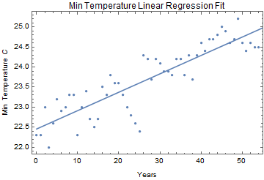**Figure 3**

Figure 4 shows the residuals from the linear regression fitted line.

**Figure 4**

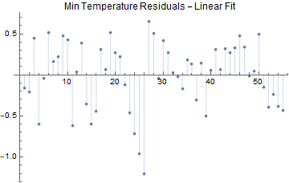

From the fitted lines, $R^{2}$ values were calculated. The values for the high temperatures and the low temperatures are as followed:

$$R_{max}^{2}=0.6520$$

$$R_{min}^{2}=0.7616$$

Further exploration of the data led to a quadradic fit being performed on the data as well. However, this fit was found to be insignificant. The linear fit model was determined to be the best model for the data. It was also found that there is an increase in both the average yearly high and average yearly low temperatures over the period that the data was collected.

There are still some questions regarding the data that was collected. Moving forward it would be good to know exactly how the data was collected, as the method described before was interpreted based off a relatively vague description. The temperature data was given to us in an excel spreadsheet with 13 decimal points, which seems like an incredibly high amount of precision. Also, considering the history of the country of Togo, which gained independence just one year before the start of data collection, it would be good to investigate how they were collecting the data through time. The city of Lomé also went through a large amount of urbanization during this time, so considering the side effects of urbanization on the city could shed light on the increasing temperatures.