Mini Project 1

Sally Dufek, Adam May

# Kouma-Konda Average Minimum Temperature

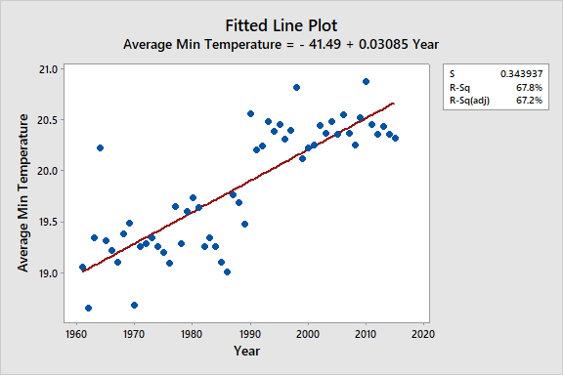

There does seem to be a potential outlier from 1964, which does not follow the linear trend. Around 1990, there seems to be a jump in the average minimum temperature.

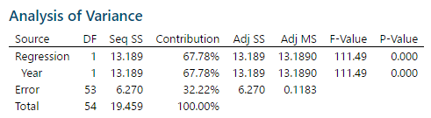

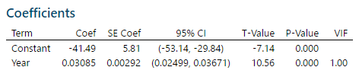

There is evidence that the Kouma-Konda average minimum temperature has significantly increased from 1961 to 2015 (t-value=10.56, p-value<=0.000). We are 95% confident for every additional year, the mean minimum temperature is increasing by between 0.02499 and 0.03671 degrees Celsius, on average. The simple linear regression model



is the most appropriate.

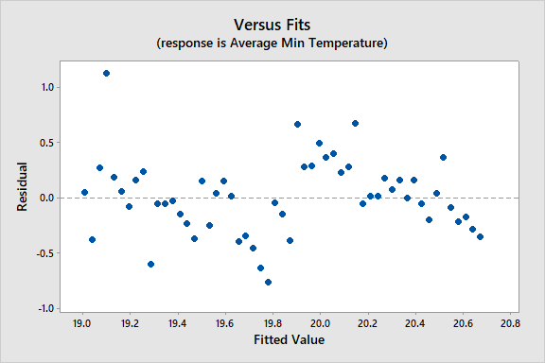

The residuals highlight the potential outlier from 1964 with a temperature in Celsius of 20.2. There does appear to be some pattern in the residuals with a discontinuity in the middle.

# Kouma-Konda Average Maximum Temperature

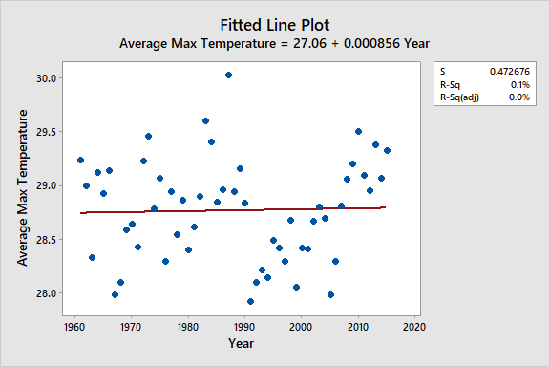

Looking at the average maximum temperature over time, there appears to be a potential outlier in 1987 and it is not clear whether the average maximum temperature has significantly increased over time.

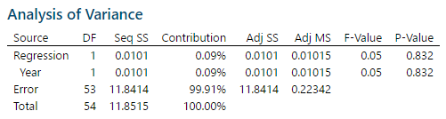

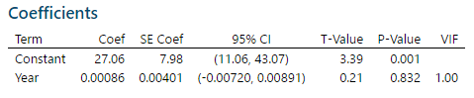

There is not enough evidence to suggest that the Kouma-Konda average maximum temperature has significantly increased from 1961 to 2015 (t-value=0.21, p-value=0.832). Because of the high p-value, time appears to be a poor predictor of average maximum temperature, thus a linear regression model does not seem to be appropriate.



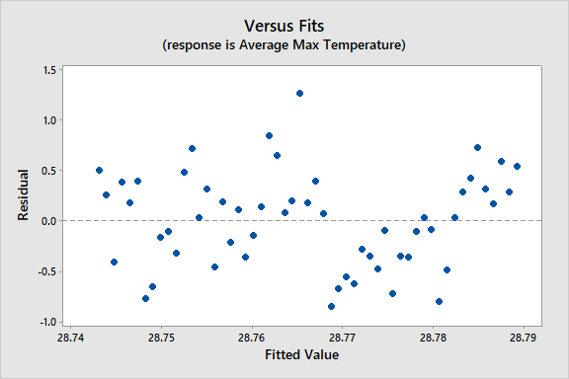

A pattern in the residuals can be seen beginning in 1991, where there seems to be a positive linear until 2015.

Additional Information

1. What is the altitude of Kouma-Konda?
2. Was the same instrument used for all measurements? What was the quality of the instrument?
3. At what time intervals were the measurements taken? Were they regular?
4. Was the measurement taken in the same location every time?
5. What precisely is the "average" temperature?
6. Could we have the original datasets?