Leah Gillespie

Dr. Long

MAT 375

April 29, 2018

Tabligbo Final Model

**Minimum Temperature Model**

The graph below shows the model for the minimum temperatures, which appears to be a decent fit for the minimum temperature data. The model captures a majority of the data points with the exception of a few data points towards the bottom, and it not as low as it used to be. The R-Squared is 0.5894731, which is not the best. However, the R-Squared has greatly improved from the preliminary model’s R-Squared of -0.312. The residuals have also improved, and they are more centered around 0. There is a slight curved pattern in the residual plot, and they could be more spread out. There is nothing too concerning in the residuals. The histogram of this model is slightly skewed to the right, and it not as normal as I would have liked to see. The histogram is at least centered around 0 unlike the histogram from the previous model. I do not believe that this model is best fit for the minimum temperatures of Tabligbo, but the model could be worst.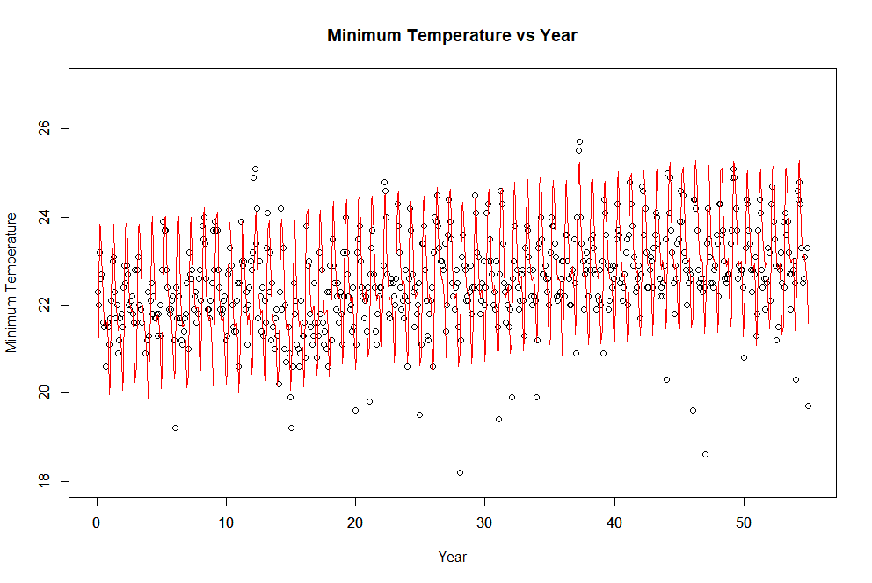

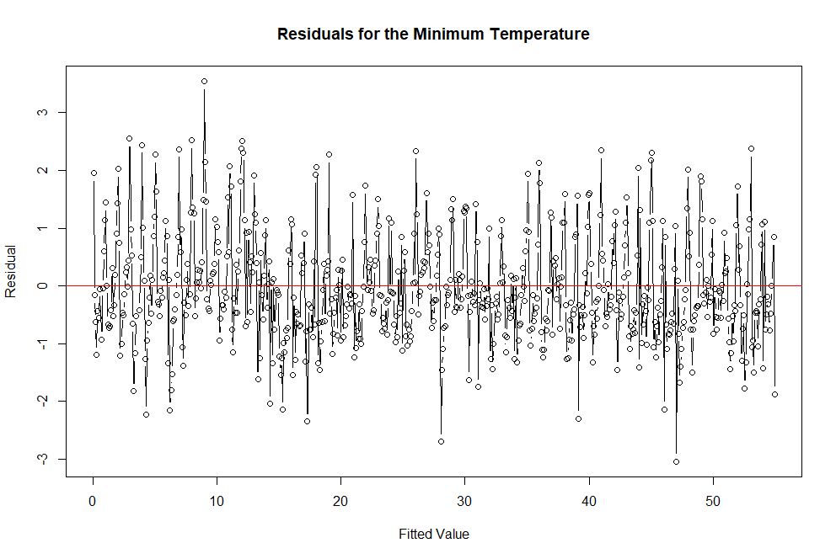

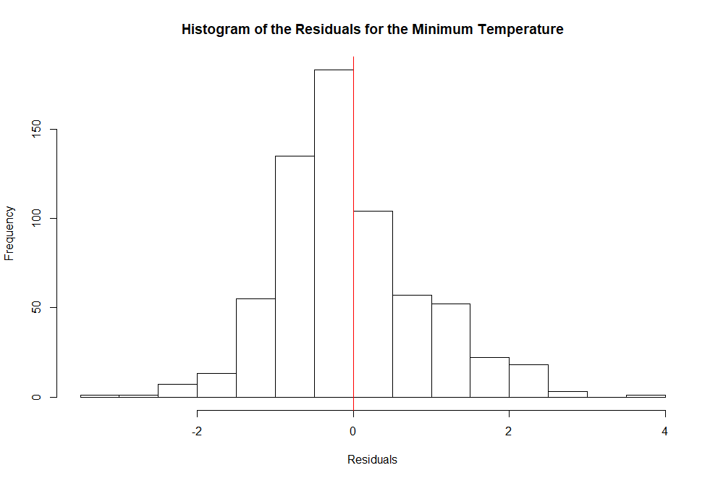

**Maximum Temperature Model**

The graph below is the model of the maximum temperatures, which appears to be a much better fit compared to our minimum temperature model. There a few data points that model does not capture, but the model captures most of the data points. The R-Squared is 0.8299975, which is also a great improvement from the preliminary model’s R-Squared of 0.238. There is a bit a curved pattern in the residual plot, but it is not horrible. The histogram has improved from the preliminary model’s histogram because it is center at 0. The histogram is also no longer skewed to the right. I believe that this a decent fit for the maximum temperatures of Tabligbo.

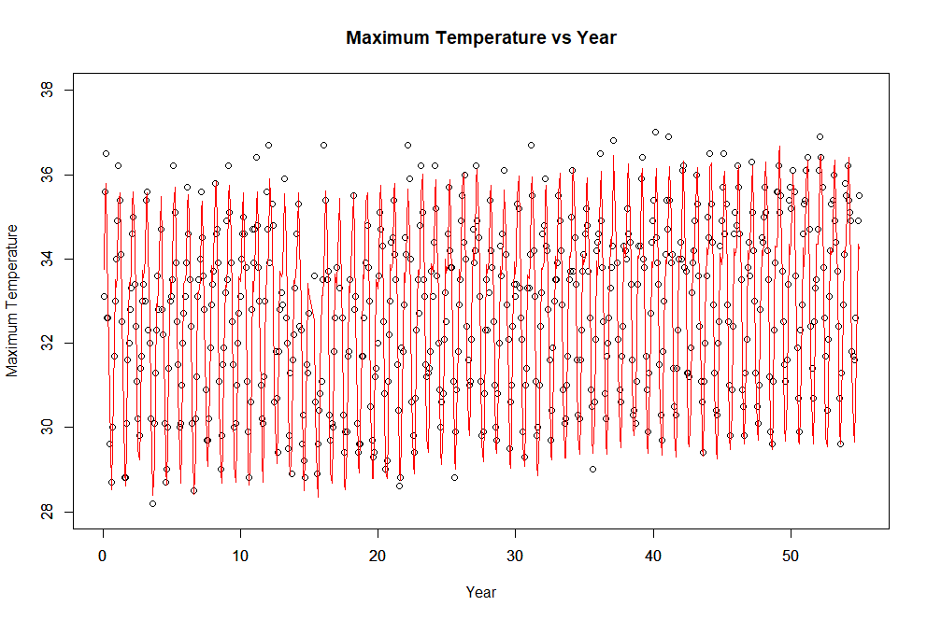

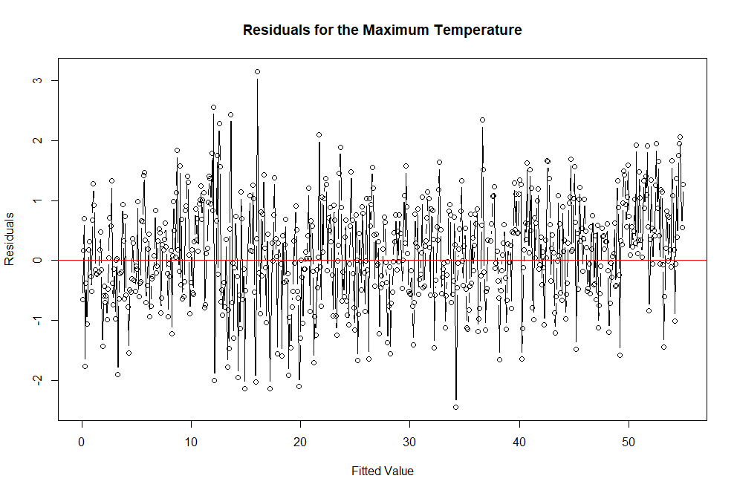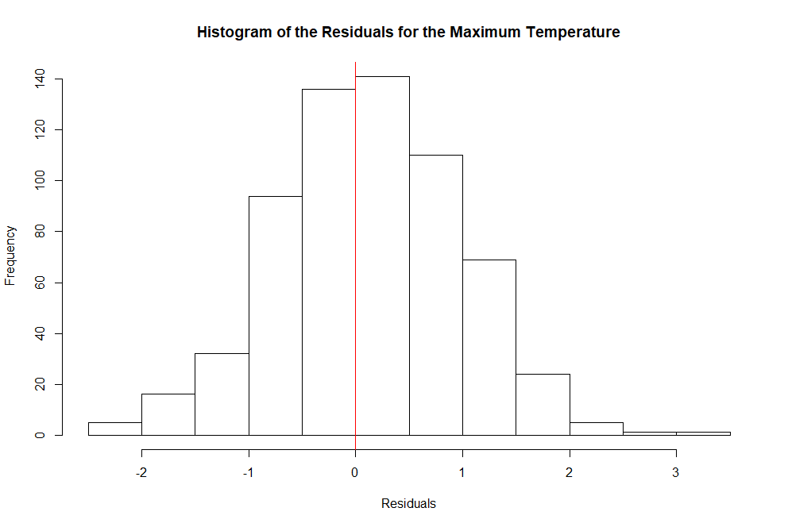

**Rainfall Model**

The graph below shows the model for the rainfall, which does not appear to be the best suited for the data. There are many data points of higher values that the model does not incorporate. The R-Squared is 0.2698506, which is undesirable. The residual plot does not have a definite curved pattern, but the residuals could be more spread out. There is nothing super concerning in the residuals. The histogram is fairly centered around 0, but I would have liked to see the distribution to be more normal. I do not think this model is a great fit for the rainfall data of Tabligbo.

