2NKU Program Application Instructions

Visit https://apply.nku.edu and select the Undergraduate Application
You will be asked to either create an account or log in under an existing account. If you have applied to NKU before in any capacity, you can log in and information will be pre-populated for you.
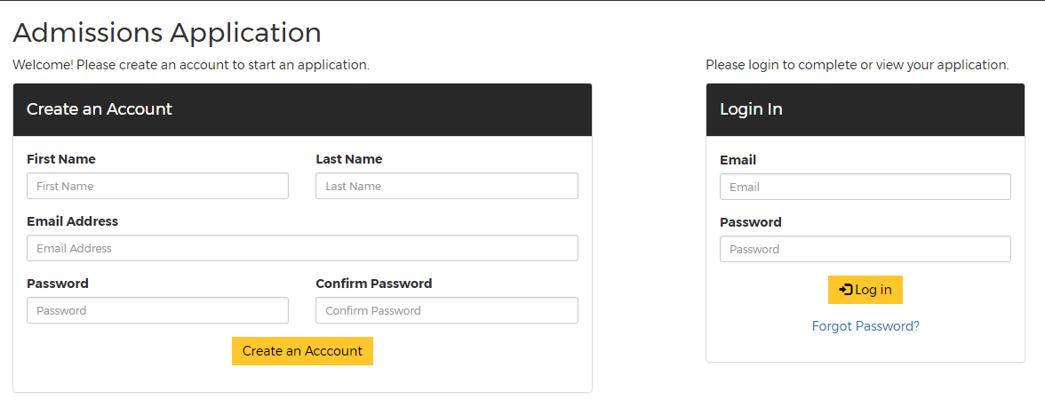
Once logged in, you can begin the application. To move to the next page in the application, select Save and Continue each time.
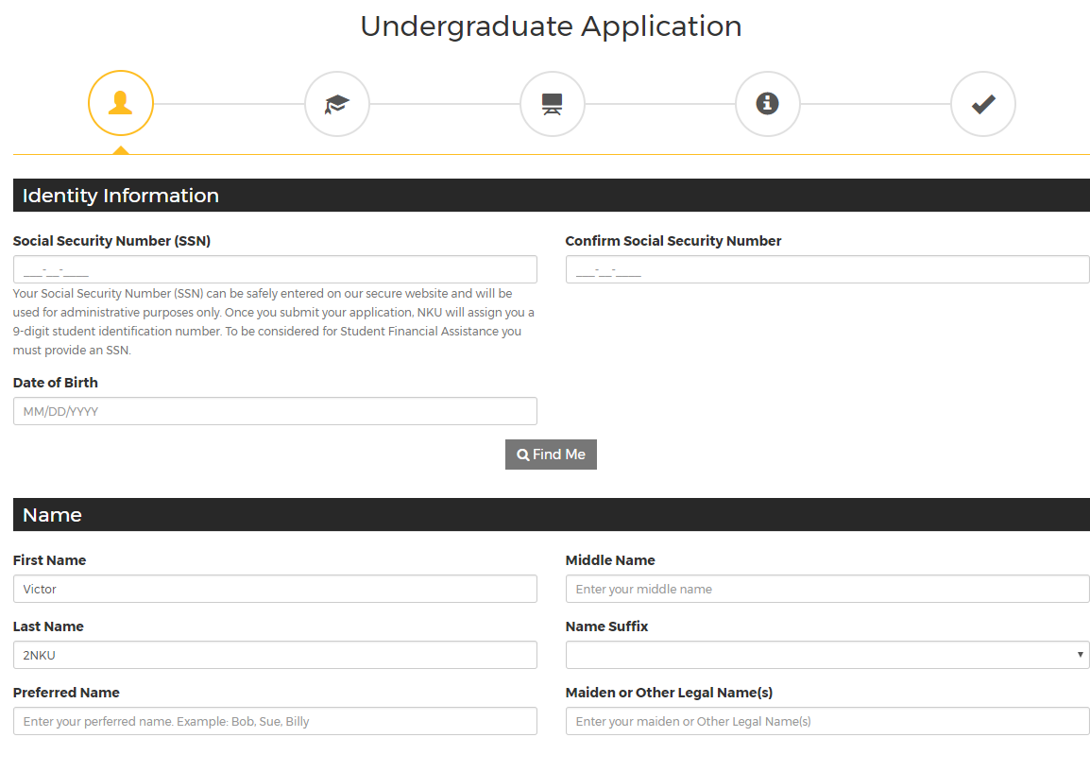
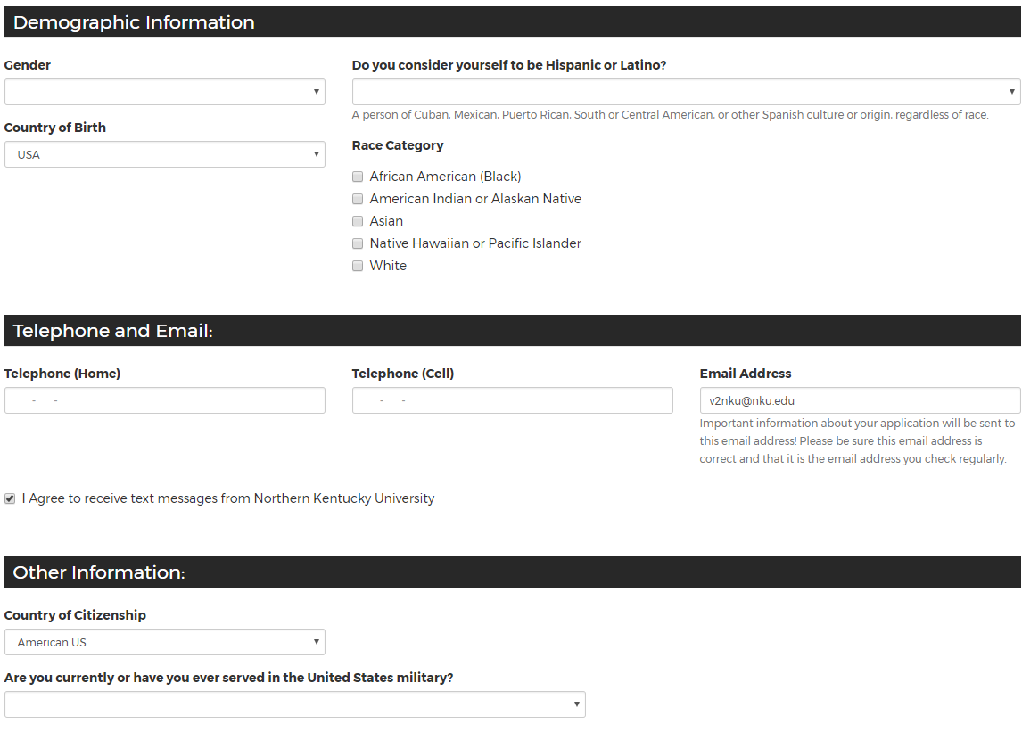
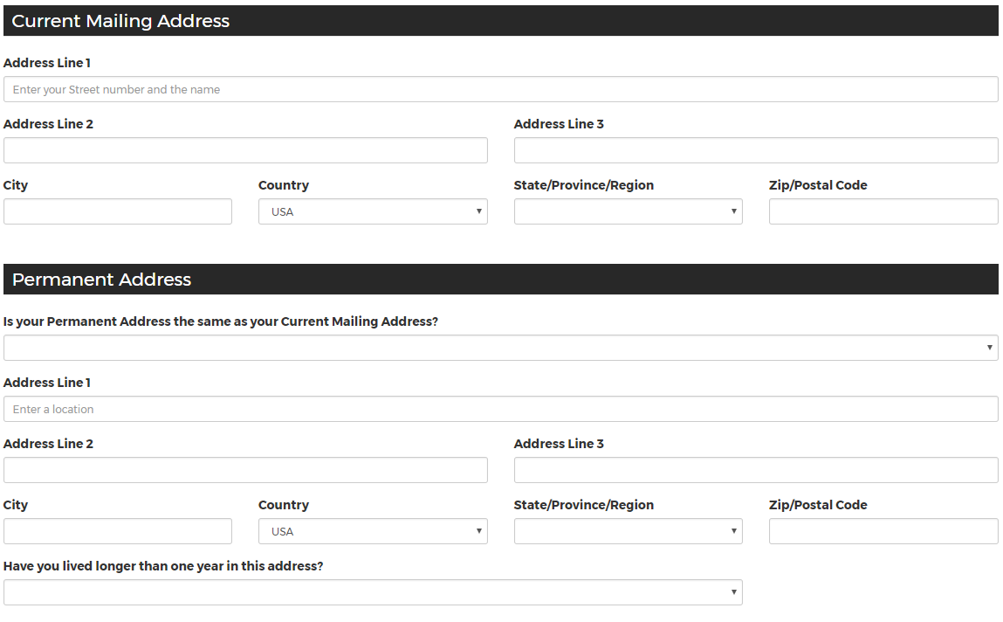

The most important part of completing the application is this. When you get to this page, you MUST select your degree type as Non-Degree. Then, you will get the option to select “2NKU Program” in the next drop down box.
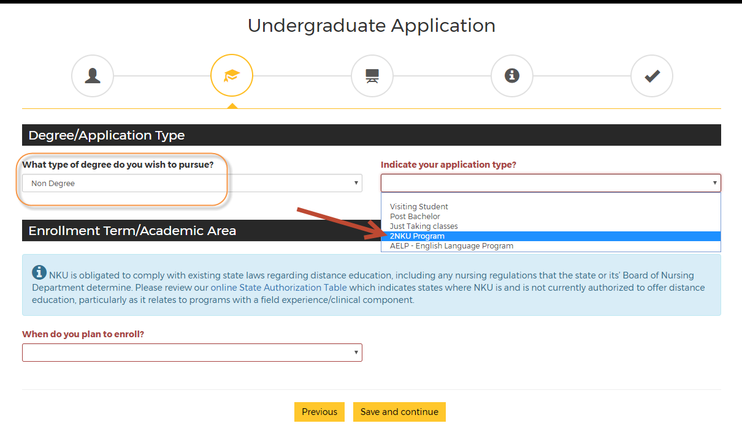
The next portion of the application asks for your education information. You will need to provide your high school or GED information, along with the colleges you have attended. In order to do this, select the “Click Here to Find Your College” button. You can add multiple schools.
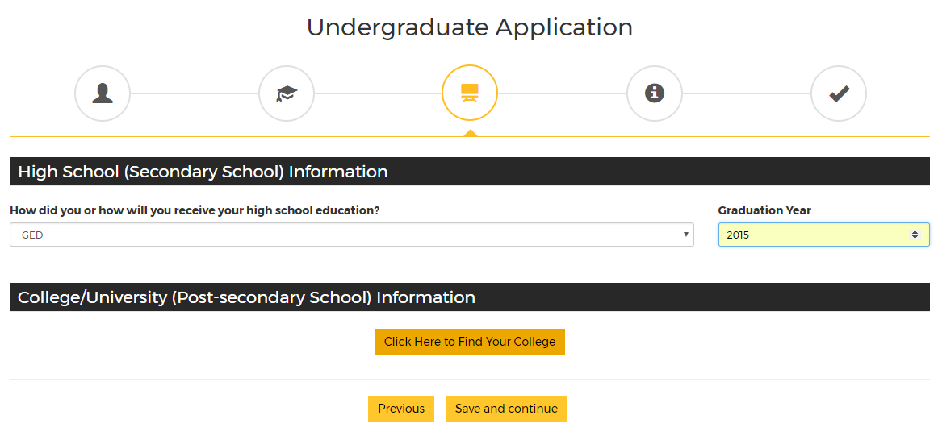
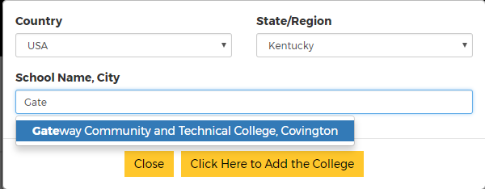

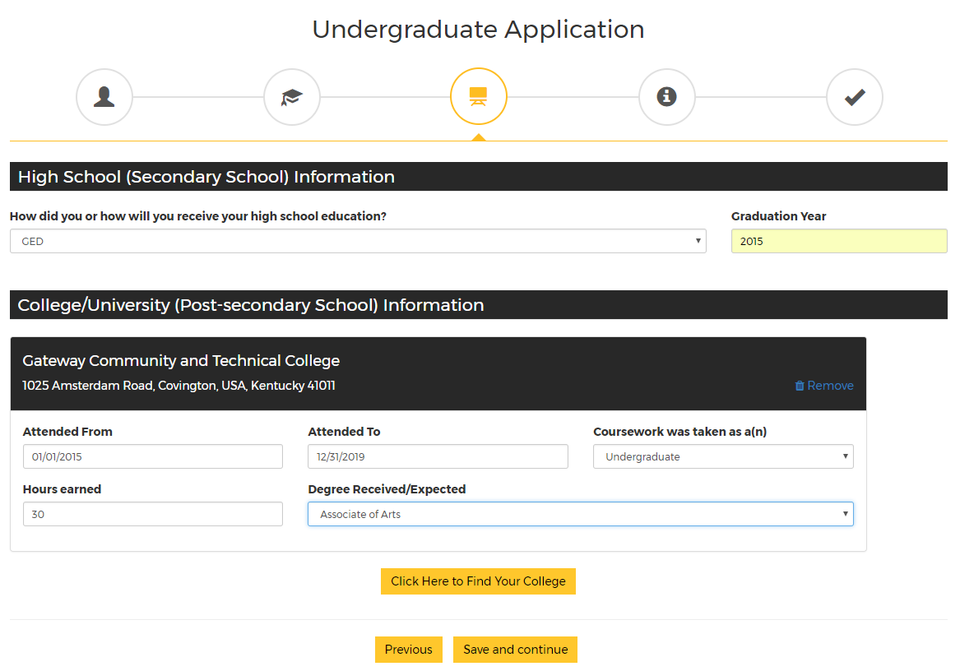

The Final page asks for your Student ID at your current school (i.e., Gateway, Cincinnati State, JCTC, MCTC). Once you complete this page, you are ready to submit the application.
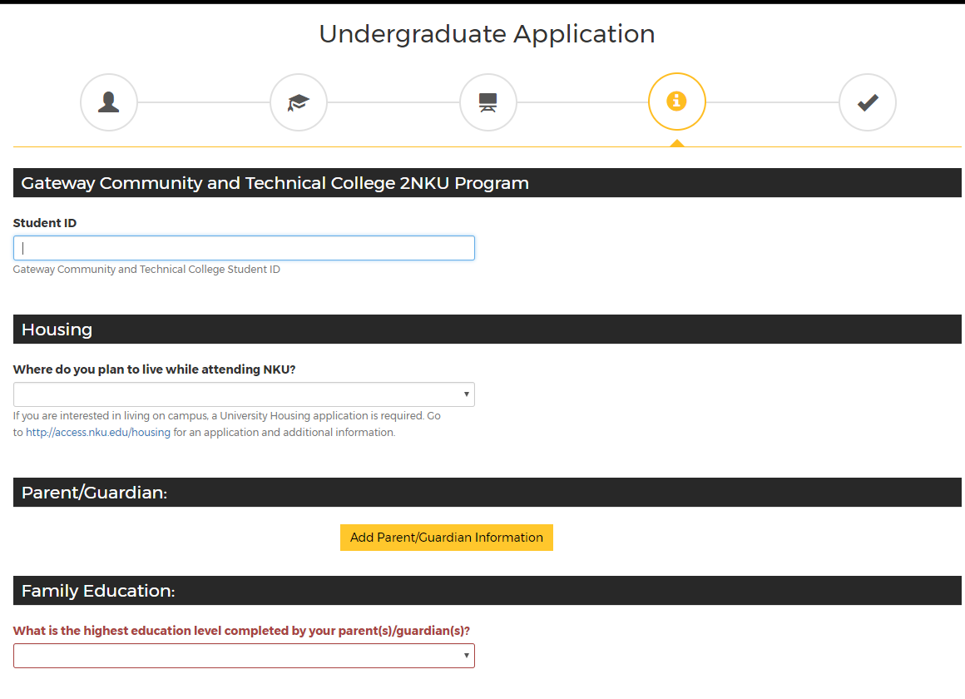
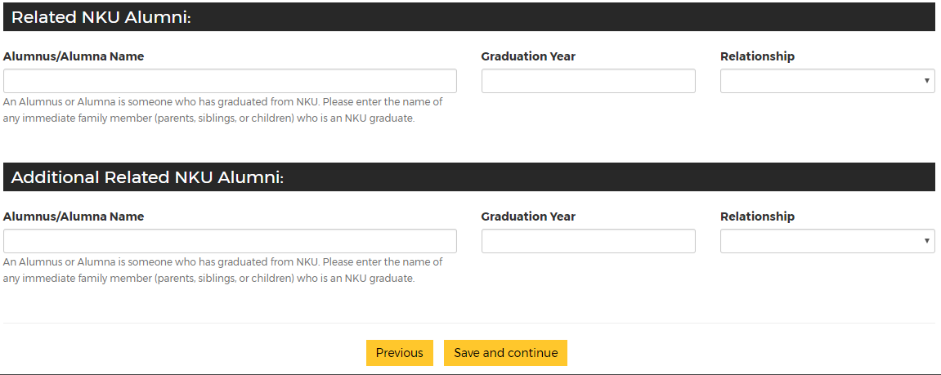

Before submission, this page will appear. Please disregard the application fee bullet—this is waived for 2NKU program applicants. Also, note the highlighted bullet point below.
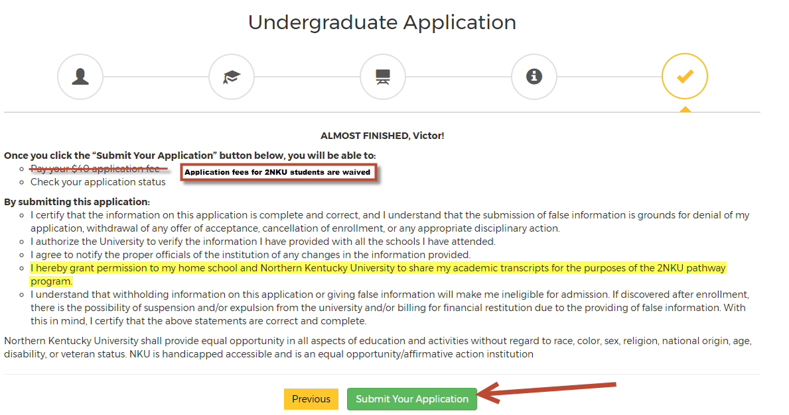

Submit the application, and you’re all finished! You will be notified by NKU when your application has been reviewed and provided with your next steps!

If you have any questions or need any assistance with the application, please contact Kelsey Bevins at NKU at bevinsk1@nku.edu or 859-572-5990.

